Weidmüller announces partnership with Fortinet to secure OT environments

Nuremberg, Germany – At the Smart Production Solutions (SPS) trade fair, Weidmüller, a pioneer in industrial connectivity and electronics, announced a strategic partnership with Fortinet, one of the global cybersecurity leaders driving the convergence of networking and security, that will provide robust cybersecurity competencies for operational technology (OT) environments. The collaboration targets the emerging need for strong cybersecurity due to increasing IT and OT convergence – the trend structurally changing the face of industries worldwide.

As industries confront growing cybersecurity threats and increasing regulatory changes, Weidmüller will partner with Fortinet to produce an integrated solution that simplifies the deployment of cybersecurity for industrial customers. Fortinet proactively addresses these challenges by providing comprehensive solutions that facilitate the integration of cybersecurity into industrial processes through collaboration. The cutting-edge cybersecurity technology crafted by Fortinet, effortlessly weaved into the hardware by Weidmüller, provides a cohesive and secure basis for both critical infrastructures and industrial systems.

“Cybersecurity is a key element in robust and sustainable production environments. In cooperation with Weidmüller, we can expand deeper into OT applications and offer our customers secure, scalable, and easily deployable solutions for protecting their assets,” said Joe Sarno, Executive Vice President of International Sales at Fortinet.

By integrating Fortinet's advanced security software with Weidmüller's robust hardware, customers are assured of having a seamless deployment experience that is enabled by thorough implementation guides and an extensive support network. This partnership not only mitigates cybersecurity risks but also ensures compliance with fast-evolving regulations such as NIS2, the Cyber Resilience Act and other global cybersecurity initiatives.

Weidmüller is committed to providing reliable solutions that will benefit customers for many years to come. “The cooperation with Fortinet extends the range of protection of the special characteristics that exist in industrial networks towards a holistic portfolio of cybersecurity solutions. Together, we offer our customers the confidence that their business is protected," said Dr. Thomas Bürger, Head of Automation Products and Solutions at Weidmüller.

With this partnership, Weidmüller will become a member of Fortinet's industry leading Open Fabric Ecosystem with over 400 partners and 800 integrations. Nearly a third of these fabric partners are integral to OT/IoT environments and offer simplified, integrated solutions for customers in key markets such as utilities, process, energy, transportation, and factory automation. Weidmüller empowers customers with innovative solutions to connect and proactively secure their OT networks, meet compliance requirements, and adapt to the highest industry standards in cybersecurity, and this will be significantly bolsteredby integrating with leading cybersecurity technologies from Fortinet.

3170 characters including spaces

Image source: Weidmüller

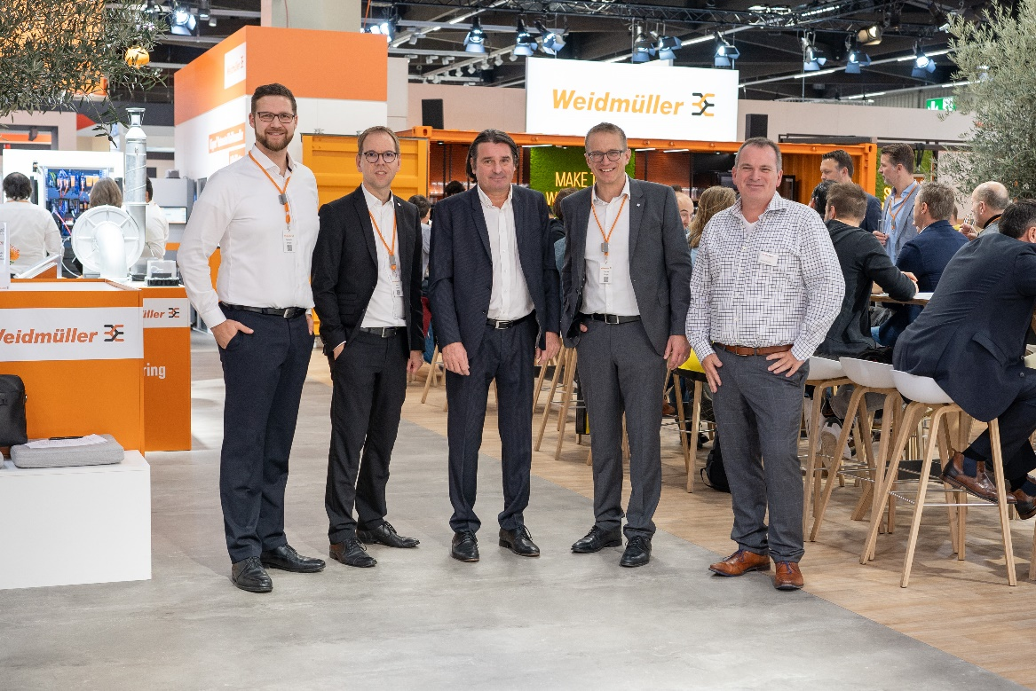
Image Caption: Sebastian Stelzer, Group Lead Product Management Industrial Ethernet (Weidmüller); Dr. Björn Griese, Head of Product Security (Weidmüller); Christian Pellkofer, Manager System Engineering OT/IoT (Fortinet), Dr. Thomas Bürger, Executive Vice President Automation Products and Solutions (Weidmüller); Roland Renner, Business Development Manager- Operational (Fortinet) announce partnership at the SPS trade fair in Nuremberg, Germany

The Weidmüller Group
Smart Industrial Connectivity: Electrification, automation, digitalisation, electrical connectivity, electromobility and renewable energies – markets in which Weidmüller feels right at home. The family-owned company established in 1850 has production facilities and sales companies in over 80 countries. As a global player in electric connection technology, Weidmüller achieved a turnover of more than one billion euros in the 2023 financial year with around 6,000 employees worldwide - around 2,000 of whom work at the company's headquarters in Detmold, in the heart of East Westphalia-Lippe, Germany. What Weidmüller lives by: Diversity with respect.
Technologies and engagement for a liveable future - Weidmüller demonstrates how it approaches the topic of sustainability in its interactive sustainability brochure.

Your contact person: Weidmüller Corporate Communications
Tel.: +49 5231 14-292322
Email: presse@weidmueller.com

