Field wiring – The industrial network from a single source
Networking automation and control technology is an important aspect of wiring in the field, or field wiring. At the highest technical level, this is a smart system for transmitting controller and sensor data in industrial applications.
In addition, it serves as the backbone of modern industrial networks, which include almost all aspects of a production facility or process control system. As a comprehensive solution, it offers the option of connecting and integrating all electrical and electronic components – from sensors to actuators, control units or communication devices. This allows for comprehensive monitoring, controlling and optimisation of industrial processes. Field wiring not only ensures efficient data transmission and communication, but system reliability and robustness as well, helping to make real-time decisions based on precise data. The HDC portfolio from Weidmüller covers all power distribution needs to ensure communication. At the same time, pre-assembled solutions reduce the work required, as do technologies for quick and reliable connections in the field.
In a world where Industry 4.0 and system networking are playing a more and more important role, field wiring – which helps companies meet the demands of increasingly digitised and automated industries – is particularly relevant. It serves as the basis for efficient management, flexibility, and future reliability in a complex industrial environment. Increasing modularisation, which is ever more essential for tapping into greater potential effectiveness and efficiency, further elevates the importance of field wiring. Weidmüller, with its extensive product line and broad experience, is the right partner for field wiring.
Maximum performance, minimum downtimes in field wiring
Industrial field wiring from Weidmüller is well-established in factory automation, machine construction and intralogistics, in particular in the challenging IP67 environment. The company offers a comprehensive selection of components with reliable, integrated IP67 technology. Weidmüller’s expertise ranges seamlessly from switch cabinet wiring to the field to machine communication. The company’s broad, well-coordinated product line is the essential foundation for successful field wiring. It includes innovative plug-in connectors, products for the switch cabinet wall, and intelligent automation solutions. This diversity allows the company to serve a wide range of industrial requirements and develop customised solutions. In addition, the family-owned company offers expertise in extensive services and sales channels. This ensures seamless integration, commissioning and maintenance of systems, improving system service life and reliability. Weidmüller utilises a holistic approach with a diverse range of sales channels, competent advising and comprehensive services, simplifying solution purchasing and implementation.
Decentralisation and modularisation as key components of industrial field wiring
Decentralisation, digitalisation and modularisation are the key components influencing efficiency and flexibility in industrial field wiring, including at Weidmüller.
Decentralisation
Decentralisation means that controller and communication components are installed closer to the processes or systems themselves. The advantage of this approach is that cabling is shorter and more customised, saving space and reducing costs. Weidmüller offers decentralised solutions such as fieldbus and Ethernet modules that facilitate seamless integration into field wiring and improve flexibility and scalability.
Modularisation
Modularisation, in contrast, also includes the use of standardised, exchangeable components and modules in order to simplify system design and maintenance. Weidmüller’s product range includes many modular components. These range from plug-in connectors to sensor-actuator boxes, cable entry systems and housings that make customised solutions possible and are reusable and flexible for users. This helps reduce downtimes during maintenance work and makes systems simple to update.
Overall, decentralisation and modularisation improve the overall efficiency of field wiring and simplify maintenance, helping meet the demands placed on industrial wiring systems.

Weidmüller as a competent complete provider – from switch cabinet wiring to machine communication
Many years of experience in working with customer applications have given Weidmüller, an electronics and connectivity company, a deep understanding of the needs and challenges its customers face. This allows Weidmüller to offer customised solutions perfectly tailored to individual applications.
Thanks to its extensive experience with a wide range of customers, the company is able to seamlessly provide the right components for any system. Weidmüller also offers all required components in a product family from a single source, as a “solution basket”. The company’s portfolio is specifically oriented to the individual customer’s application and offers a wide range of solutions – from the switch cabinet wall with products such as FrontCom® Vario or Micro, the cable entry system Cabtite and heavy-duty connectors, to the field with sensor-actuator interfaces, Industrial Ethernet and FieldPower®, and even into the machine with Weidmüller industrial lights. Data, signals and power – Weidmüller stands for comprehensive connectivity and performance.
Overall, Weidmüller offers comprehensive solutions for the entire spectrum of electrical engineering, ensuring seamless integration of all required items in different applications.
“We offer customers a complete product line for the field level. Everything that connects systems together – the nervous system of the field level, so to say” explains Karola Tillack, Vice President of the Business Unit Field Wiring at Weidmüller.
The Weidmüller product line includes:
- Heavy duty connectors
- Connection lines, patch cables and cables
- Circular connectors
- Single Pair Ethernet plug-in connectors
- Industrial lights
- Filter fans
- Cable entry systems
- Housing solutions
- Industrial Ethernet

6,147 characters including spaces
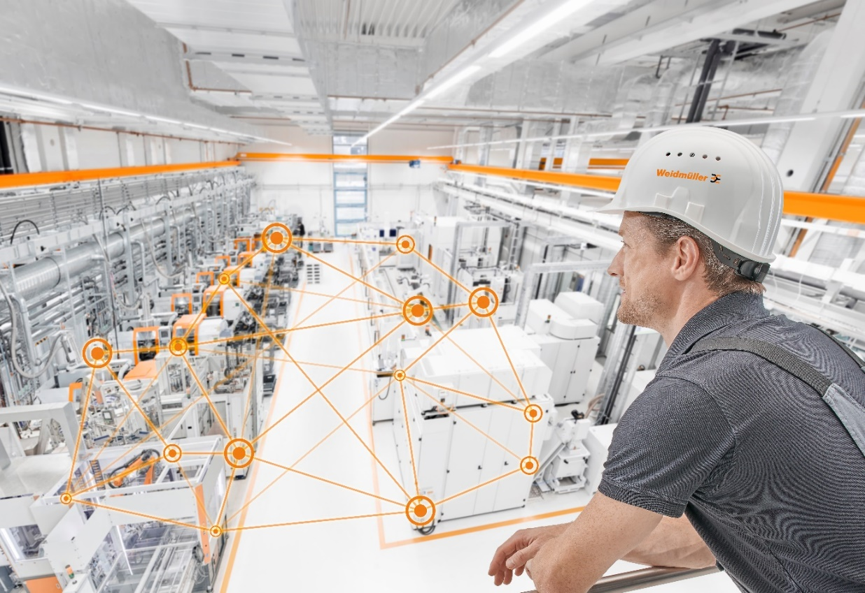

Image caption: Field wiring – The industrial network from a single source

The Weidmüller Group
Electrification, automation, digitalisation, electrical connectivity, electromobility and renewable energies: with Smart Industrial Connectivity, the Weidmüller Group is navigating the dynamic markets of the world – and leading the way with technological innovations and a genuine pioneering spirit. Weidmüller makes processes simpler and better and develops solutions for a future worth living. Founded in 1850, the family-owned company from Detmold feels at home all over the world: the Group has production facilities, sales companies and representatives in more than 80 countries. In the 2022 financial year, Weidmüller with its team of 6,000 employees worldwide generated sales of more than a billion euros.
Image rights: Weidmüller

Responsible for content:
Company Spokesperson, Sybille Hilker

Contact:
Weidmüller Corporate Communications
Tel.: +49 (0) 5231 / 14-292322
Email: presse@weidmueller.com

