The threads in your hand

How embroidery machine manufacturer Lässer AG uses the cloud-based remote access u-link

Service calls used to be an integral part of everyday working life for the Swiss embroidery machine manufacturer Lässer. If a customer ordered a machine, the system specialist had to be on site at the latest for maintenance or in the event of a fault. Today, this is carried out from the company headquarters in Switzerland, as Lässer can access machines from any location via the u-link remote access service.

Lässer AG
When fashion with sophisticated embroidery is presented on international catwalks, Lässer has often contributed to the success of the collections. With 180 employees, the family-run company is one of the world's leading manufacturers of high-performance embroidery machines. The machines, which can be up to 30 meters long, must guarantee accuracy and smooth running to precisely apply the filigree works of art made of thread to different materials such as silk, cotton or tulle.
Lässer maintains a high standard of service to ensure safety after the purchase, as machine downtimes are a high-cost factor for plant operators. However, on-site visits by technicians are uneconomical in the digital age: the availability of specialists and travelling to the plant operator if necessary, costs time and money. As a result, u-link, Weidmüller's remote access service, is now used to maintain Lässer's embroidery machines. This enables Lässer to access its machines worldwide and across national borders.

The simplified service
A VPN client is installed on the service technician's computer, which is used to establish a secure, outgoing connection with a meeting point server (cloud server). This is used to establish a continuous VPN tunnel from the router to an industrial security router on the operator's machine. Lässer now uses Weidmüller's industrial security routers in each of its embroidery machines. A total of several hundred routers have already been installed.
In the event of a fault, the machine operator can decide whether and when Lässer is granted access to a machine. Once the service technician has logged into the u-link portal, he can see which industrial security router has established a VPN connection to the Meeting Point server. He can now connect to the router and view the system visualisation and parameters of the control system. For example, he can see in which program section the machine has failed. Remote access allows Lässer to significantly reduce the time between reporting a fault to the service team and restarting the machine. Regular machine updates are now also carried out via the remote access service as standard.

Extensive testing desired
The desire for remote access already existed when Peter Hirt, Segment Manager Machinery & Automation Sales at Weidmüller, visited Lässer for the first time. The decision in favour of u-link was made after Patrik Schwarz, software developer and project manager at Lässer, was convinced by the solution in practice. Using a sample router and test access to the web application, he was able to test the functions of u-link in advance. During the system design and setup, regular online meetings were held between Lässer and Weidmüller to discuss important issues such as the assignment of rights or firewall settings. Even specific requirements of the Swiss company, such as configuration and control of the router via the machine control system, were implemented.
The issue of data security and the location of the servers also played a role in the initial planning phase, as it is not uncommon for providers of remote maintenance solutions to outsource their cloud storage to countries whose data protection laws do not meet German standards. All servers accessed by u-link, on the other hand, are located in Western Europe and fulfil all relevant security standards.

In an extensive project like this, consistent information is the basis for successful collaboration. Today, the remote access solution is being continuously improved thanks to the close dialogue between Lässer and Weidmüller. For example, an interface was recently implemented from the u-link portal to the controllers and the development portal so that the router can be configured from there. The further development of customer service is an important topic for the future at Lässer.

4360 characters including spaces

All images are freely available. You can download them from the following link:
https://www.picdrop.com/weidmueller/Jth9F3VJDt

Image source: Weidmüller

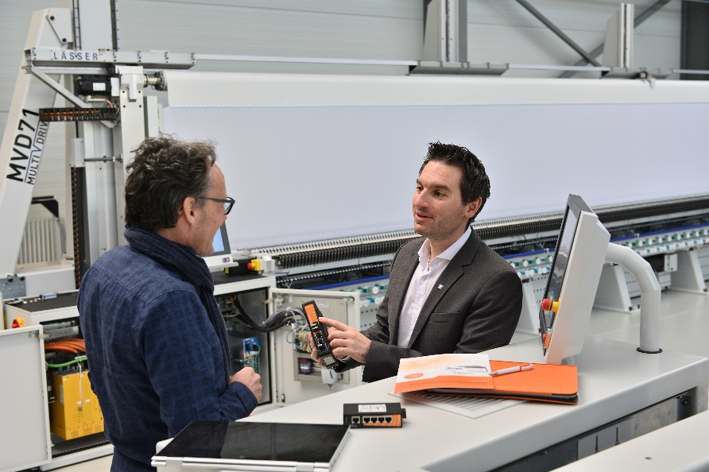
Image caption: In front of the MVD71 embroidery machine, Peter Hirt explains the advantages of Weidmüller's Industrial Security Router to Patrik Schwarz

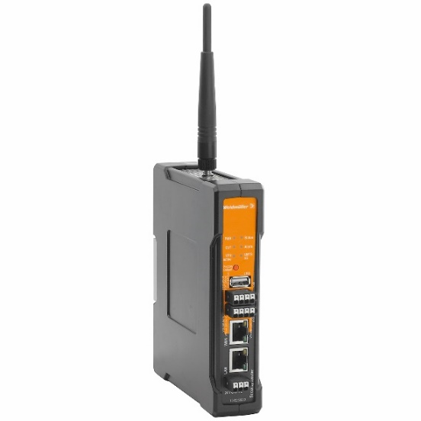
Image caption: Weidmüller's industrial security routers enable secure remote maintenance

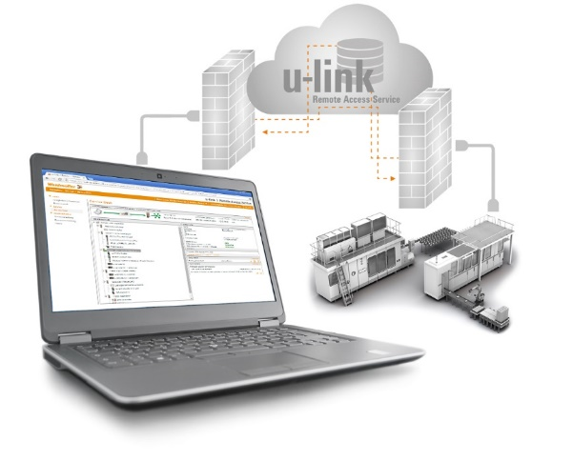
Image caption: u-link provides fast and secure access to machines and systems. It also enables efficient management of production systems, user clients, access rights and firmware versions.

The Weidmüller Group
Smart Industrial Connectivity: Electrification, automation, digitalisation, electrical connectivity, electromobility and renewable energies – markets in which Weidmüller feels right at home. The family-owned company established in 1850 has production facilities and sales companies in over 80 countries. As a global player in electric connection technology, Weidmüller achieved a turnover of more than one billion euros in the 2023 financial year with around 6,000 employees worldwide - around 2,000 of whom work at the company's headquarters in Detmold, in the heart of East Westphalia-Lippe, Germany. What Weidmüller lives by: Diversity with respect.
Technologies and engagement for a liveable future - Weidmüller demonstrates how it approaches the topic of sustainability in its interactive sustainability brochure.

Your contact person: Weidmüller Corporate Communications
Tel.: +49 5231 14-292322
Email: presse@weidmueller.com

