Weidmüller VARITECTOR PU: Surge protection for photovoltaic systems

Compact design and VARITECTOR protective technology for maximum system availability. Five pole surge protection for 1,500 V DC applications.

Ensuring the long-term profitability and efficiency of photovoltaic systems, a key technology for the energy transition

Each year, rooftop photovoltaic systems and photovoltaic parks are being installed that generate hundreds of megawatts of current. To protect this investment in terms of system availability and safety, lightning and surge protection must be included starting from the system design phase. Lightning strikes and network disruptions can result in expensive repairs and downtimes. Protecting against lightning and surge voltage helps minimise financial risks and ensure the long-term profitability of the photovoltaic system. Now, Weidmüller is adding a five-pole, type I + II variant for two MPPTs to its surge protection portfolio. With the new five pole VARITECTOR PU PV I + II 5 1,500 surge protection, you can protect your systems with the latest, space-saving technology.

Photovoltaic systems are a sustainable and environmentally friendly way to generate power and are one of the most popular investments in renewable energy.
However, PV systems are directly exposed to environmental influences due to the fact that they are normally installed in exposed locations. The likelihood of a direct or nearby lightning strike and resulting surge voltage is very high. The negative impacts of a lightning strike can be felt for up to two kilometres away. Because of this, choosing and installing effective surge protection is essential to ensure the reliability and service life of the system.

The new five pole PV surge protection from Weidmüller integrates both type I and type II protection in a single unit. This provides complete fuse protection against direct lightning strikes (type I) and indirect surge voltage (type II).
Since both types of protection are integrated in a single unit, system planning is also simpler and more efficient.
This can help save on installation costs, since fewer separate components are required. Standard conformity according to the latest version of IEC/EN 61643-32 ensures the systems can be used internationally.

The five pole VPU PV is equipped with plug-in arresters. This allows for fast and cost-efficient exchanges – even of individual arresters – without tools. The integrated status indicators for the individual arresters simplify visual inspections and checks of components. With a joint potential tap point, two MPP trackers are protected with just one product – at an installed width of just 5 TE. This saves time, costs and space. The surge protection arrester is designed for PV systems with system voltage of 1,500 V DC. One of the main advantages of 1,500 V PV systems is that they improve efficiency. Increasing the operating voltage makes it possible to transmit higher power levels, leading to improved energy production.

The new VPU PV surge protection devices have a maximum short-circuit resistance, i.e. PV systems with lots of solar panels in one string are protected with up to 11 kA of the maximum short-circuit current. Further protective elements are not required.
Often, photovoltaic systems are installed at heights of up to 4,000 meters. Surge protection devices from Weidmüller are designed to reliably protect PV systems even in these exposed locations. An additional risk assessment with a view to derating loss, which is standard for systems at these altitudes, is not required.

It should be noted that surge protection for PV systems always has two sides: appropriate surge protection is required on both the direct current (DC) and alternating current (AC) sides to protect both areas. With over two decades of experience in surge protection, Weidmüller offers a pioneering and comprehensive range of products for both DC and AC protection. Effective lightning and surge protection elements help extend the service lives of electronic components in the photovoltaic system and AC installation. This is key for long-term, reliable energy production.

Ready-to-assemble solution for quick installation
In addition to the components listed above, Weidmüller offers fully assembled combiner boxes for protection against overvoltage in PV systems. In this case, the overvoltage protection is integrated and wired into an IP65 enclosure. Connection is easily made via PV connectors mounted on the enclosure. The earth wire is led out through cable glands. This solution also ensures comprehensive protection and simple installation for PV systems and highlights Weidmüller's commitment to innovative and user-friendly solutions.

4,715 characters including spaces

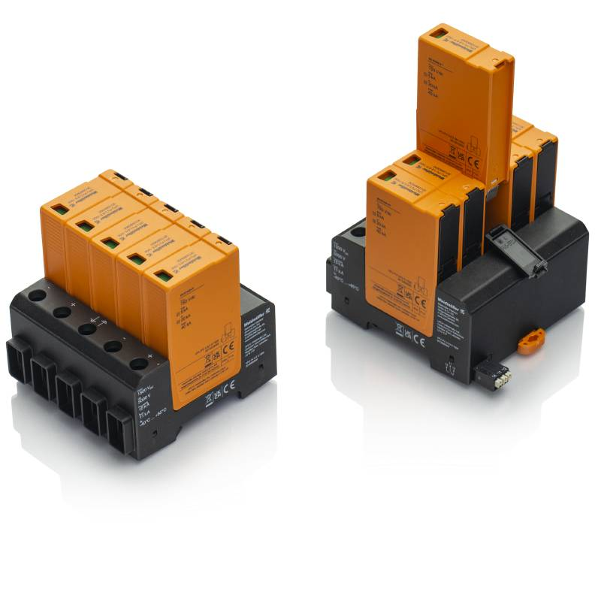
Image caption: Weidmüller VARITECTOR PU PV: for reliable and efficient operation of PV systems

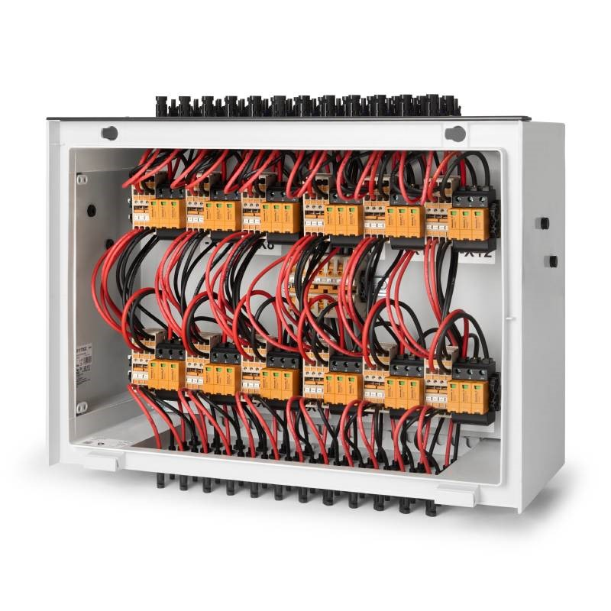
Image caption: Pre-assembled combiner box for protection against overvoltages in PV systems integrated and wired in an IP65 housing

You are free to use all images. We request that you cite the image source Weidmüller.

The Weidmüller Group
Smart Industrial Connectivity: Electrification, automation, digitalisation, electrical connectivity, electromobility and renewable energies – markets in which Weidmüller feels right at home. The family-owned company established in 1850 has production facilities and distributors in over 80 countries. As a global player in electrical connectivity, in 2023 Weidmüller reported revenue in excess of one billion euros with around 6,000 employees worldwide – approx. 2,000 of whom are located at the headquarters in Detmold in the heart of Ostwestfalen-Lippe, Germany. What Weidmüller lives by: Diversity with respect.

Technologies and engagement for a liveable future – Weidmüller demonstrates how it approaches the topic of sustainability in its interactive sustainability brochure.

Contact:
Weidmüller Corporate Communications
Company Spokesperson, Sybille Hilker
Tel.: +49 (0)5231 / 14-292322
Email: presse@weidmueller.com

