The PZ 2.5 from Weidmüller – the smallest professional crimping tool for wire end ferrules

The PZ 2.5 from Weidmüller is the most convenient way to crimp – regardless of the user’s hand size.

With the PZ 2.5, Weidmüller has developed a compact crimping tool especially for wire end ferrules in the cross-section range from 0.14 to 2.5 mm². By focusing on small cross-sections, the size, weight, opening width and operating force required for the new tool have been kept to a minimum – without compromising on crimp quality. The PZ 2.5 is currently the smallest professional crimping tool for wire end ferrules on the market.

The PZ 2.5:
- 30% more crimping comfort
The grip width, opening width and weight of the new crimping tool have been reduced by around 30%. This makes the PZ 2.5 considerably more handy and easier to use than previous crimping tools. It enables fatigue-free working, even for small hands.

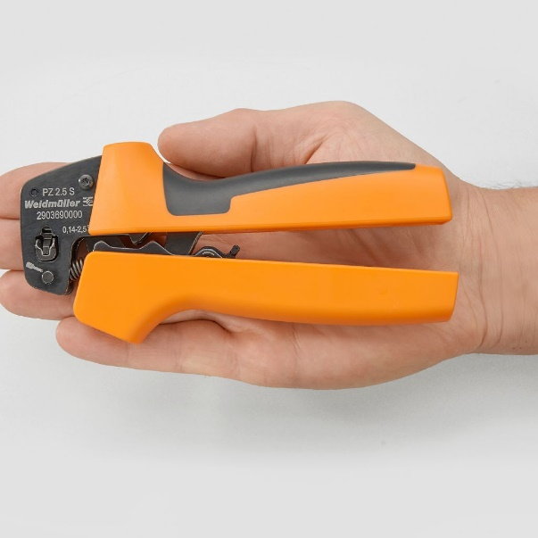
Image caption: The PZ 2.5 is the smallest professional crimping tool – the handiest way to crimp

- 100% more crimping reliability
Thanks to its practical universal joint, the PZ 2.5 prevents incorrect insertion and ensures error-free work. Moreover, the trapezoidal crimp in the cross-section range from 0.14 to 2.5 mm² complies with all current standards.

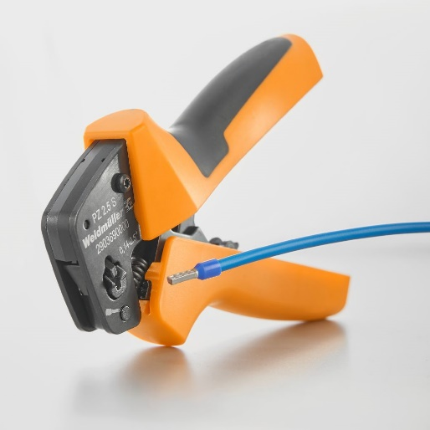
Image caption: The practical universal joint ensures error-free work and first-class crimping quality

- 200 % more durable
The focus on small cross-sections reduces the wear of the PZ 2.5 considerably. For this reason, the service life of the compact crimping tool is more than double that of other crimping tools. The crimp quality remains at a consistently high level.

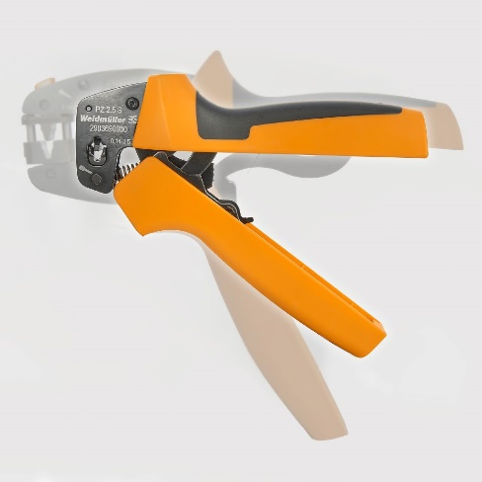
Image caption: The service life of the PZ 2.5 has more than doubled thanks to the focus on small cross-sections

1,749 characters including spaces

You are free to use all images. Please cite the source of the image.
Image source: Weidmüller

The Weidmüller Group

Smart Industrial Connectivity: Electrification, automation, digitalisation, electrical connectivity, electromobility and renewable energies – markets in which Weidmüller feels right at home. The family-owned company established in 1850 has production facilities and distributors in over 80 countries. As a global player in electrical connectivity, in 2022 Weidmüller reported revenue in excess of one billion euros with around 6,000 employees worldwide – approx. 2,000 of whom are located at the headquarters in Detmold in the heart of Ostwestfalen-Lippe, Germany.
Responsible for content:
Company Spokesperson, Sybille Hilker
Contact for this message:
Weidmüller Corporate Communications
Chantal Campos Chavero
Editor Corporate Communications
Tel.: +49 (0)5231 / 14-292322
Email: presse@weidmueller.com

