Weidmüller: Switches for the new series

The company is expanding its unmanaged switches portfolio with the EcoLine Series B

Weidmüller is launching new unmanaged switches on the market. EcoLine Series B products stand out for their particularly compact design and high performance capability. New technical highlights include expanded functions like Quality of Service and Broadcast Storm Protection.
The new switch series supports “Quality of Service”. This function prioritises data traffic and regulates the priorities between different applications and services – minimising latency times. This ensures that business-critical applications are always executed with the necessary priority. Less important tasks are handled automatically in order of priority. Because they use this principle, the switches fulfil Profinet Conformance Class A, meaning they can be used in industrial real-time networks like Profinet.

In addition to performance, network reliability is essential to ensuring the smooth operation of production lines. The switches protect the network against “Broadcast Storms”. A faulty device or faulty application transmits a flood of broadcast messages, which can result in a system failure. The “Broadcast Storm Protection” (BSP) function detects floods of messages and automatically limits them in order to maintain network integrity. This prevents potential network outages and stabilises data traffic.

The revised technology used in EcoLine Series B products allows the new devices to have a particularly small design. The narrow dimensions of the housing fit into areas with limited space. The snap-in foot, which can be rotated 90 degrees, allows for both horizontal and vertical installation in the control cabinet – allowing for it to be used even very close to cable ducts.

The industrial metal housing ensures the switches are highly robust. This protects them against impacts, vibrations and other environmental influences, ensuring a long device service life and minimising downtimes. With the new series, Weidmüller has also succeeded in reducing overall operating costs. This has been made possible by delivering energy savings of 60 percent compared to the previous model as well as thanks to the cardboard packaging, which can be recycled without being separated from other waste.

2412 characters including spaces

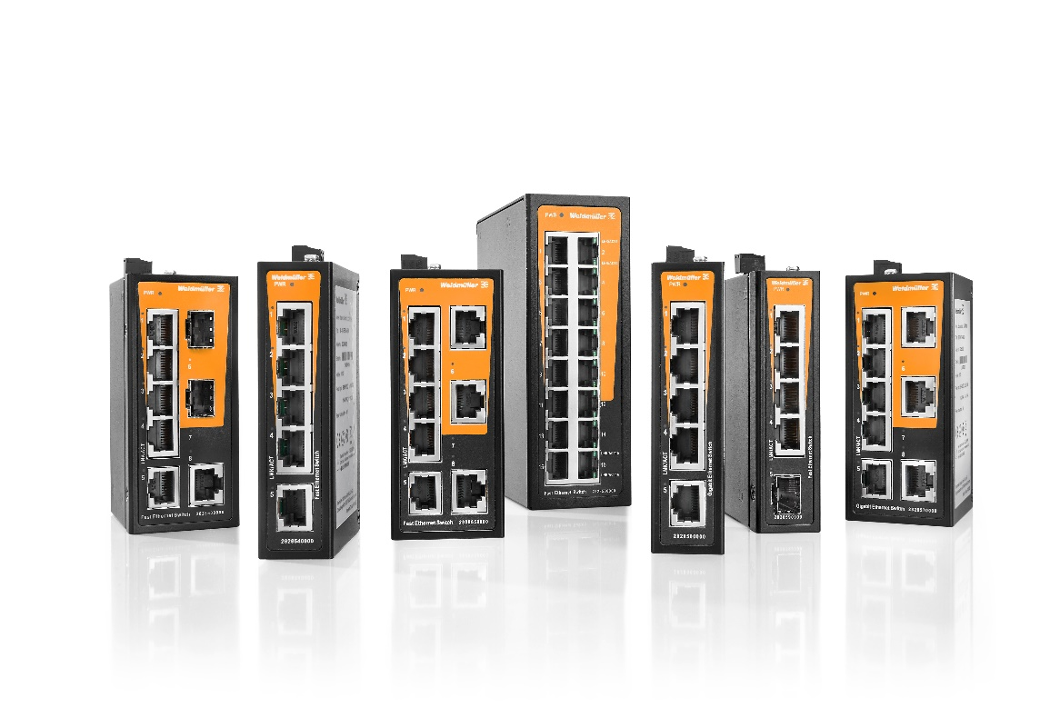
Image caption: The switches feature Quality of Service and Broadcast Storm Protection.

Your contact person: Weidmüller Corporate Communications
Tel.: +49 5231 14-292322
Email: presse@weidmueller.com

Weidmüller - Your Partner in Smart Industrial Connectivity
The Weidmüller Group has production facilities, marketing companies and representative offices in over 80 countries. Alongside its customers, the family-owned company from Detmold is shaping the digital transformation – with products, solutions and services for Smart Industrial Connectivity and the Industrial Internet of Things. In the 2022 financial year, Weidmüller generated sales of more than a billion euros with around 6,000 employees.

Responsible for the content: Weidmüller Corporate Communications
Corporate Spokesperson, Sybille Hilker

