Automation on a running conveyor
Comprehensive solutions from Weidmüller transport intralogistics into the IIoT

Decentralisation, intelligent industrial IoT solutions and visualisation are key technologies for the success of intralogistics systems. Weidmüller offers products and solutions for automation and data analysis that help users get ready for the industrial IoT.

Electronics and connection technology company Weidmüller develops IIoT and automation innovations that advance digitalisation in intralogistics. On the shop floor, the u-control M3000 and M4000 control systems ensure precise control of machinery. As edge and control systems in one, they connect IT with logistics and save space and resources. In addition to operating conveyors, cargo lifts and rotary airlocks, the u-control M3000 and M4000 collect and process data and make it available in the network, helping ensure a successful start in the IIoT.
In the network, the collected data can be converted into added value with the help of Weidmüller software. As an Enabler from Data to Value, Weidmüller gives users the software they need with the Industrial AutoML tool. The tool enables domain experts to generate their own ML models based on their application knowledge – facilitating machine learning in intralogistics without the aid of data scientists.
Web-based HMI and SCADA solutions from Weidmüller reduce costs for parameterisation and diagnostics. In addition, they allow for simple integration into higher level portals via remote access. The SCADA solutions, in particular, stand out for their modern web interfaces that can be controlled with gestures. Custom design and reporting options also make it easier to adjust to the user's specific needs. A central visualised installation can also be operated on a decentralised and remote basis via SCADA solutions from Weidmüller.
As a partner throughout all project phases, Weidmüller teams from different technological disciplines work with customers on draft concepts, then review the feasibility of the application. By doing so, Weidmüller offers comprehensive support to users on their path to automated intralogistics.

2159- characters including spaces

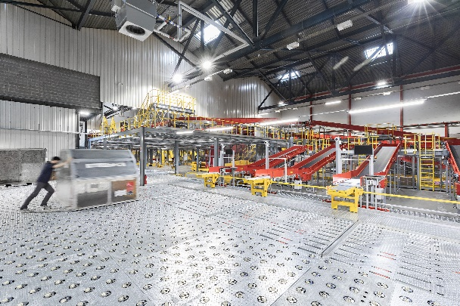
Image caption: Intralogistics benefits from Weidmüller's intelligent edge devices that make processes IIoT-compatible

Your contact person: Weidmüller Corporate Communications
Tel.: +49 5231 14-292322
Email: presse@weidmueller.com

Weidmüller - Your Partner in Industrial Connectivity
The Weidmüller Group has production facilities, marketing companies and representative offices in more than 80 countries. Together with our customers, we shape the digital transformation – with products, solutions and services for Smart Industrial Connectivity and the Industrial Internet of Things. In the fiscal year of 2021, Weidmüller reached sales of 960 million euros with around 5,300 employees.

Responsible for the content: Weidmüller Corporate Communications
Corporate Spokesperson, Sybille Hilker

