Building bridges between apps and the cloud

PROCON-Connect from Weidmüller brings machine data to the cloud

Weidmüller launches the PROCON-Connect App. The software tool enables users to easily capture machine data, pre-process it and make it available to other applications. This simplifies data exchange and speeds up installation. Users easily connect their software to each other and to the cloud.

Available for Windows, Linux and Docker

More and more companies are using open software in automation to respond flexibly to market demands. They are collecting data from the machine to implement energy management, predictive maintenance or remote maintenance. To implement these applications, users need to link the automation software in the OT and the application software in the IT. Until now, connecting the different software tools has required complex engineering or costly extensions. PROCON-Connect simplifies this process. It acts as a link between the different domains and facilitates data exchange. The application is available as a Docker container for Windows and Linux as well as for Weidmüller's u-OS operating system.

PROCON-Connect requires no programming knowledge. Users can easily connect different software applications by configuring them. PROCON-Connect is configured web-based in a browser; no separate engineering tool is required.
1) Data acquisition: Users configure the driver connections. A few pieces of information such as the source URL are sufficient to establish a connection. It is also possible to set additional parameters, such as the time between updates. Machine data is integrated with just a few clicks.
2) Data pre-processing: Data can be aggregated into internal databases or linked to metadata. Scaling factors can also be easily set. In addition, the data can also be made available to other applications via InfluxDB.
3) Data communication: Data can be easily and securely sent to the cloud using standard communication technologies such as MQTT. The data can also be sent to Weidmüller's easyConnect and ResMa solutions, where it can be further analysed as part of IIoT cloud solutions and energy and production management.

The cloud connection is also fundamentally bidirectional and allows machine data to be changed from the cloud according to the respective use case. If users need to make changes to the control systems of entire machine parks, PROCON-CONNECT enables this via MQTT. There is no need for manual adjustments or a VPN connection.

Fully integrated into the Weidmüller software portfolio

PROCON-Connect is closely integrated with Weidmüller's software portfolio. The tool connects user software such as the WEB-HMI PROCON-WEB to the Industrial Service Platform easyConnect or the energy management system ResMa® without any programming effort. The PROCON-Connect app is also included in the u-OS operating system in a free entry-level version.

PROCON-Connect perfectly complements Weidmüller's u-software portfolio. In addition to options for regression analysis in accordance with ISO 50006 and machine learning at the edge using edgeML, the company offers numerous solutions in the areas of IIoT and automation: the operating system for automation u-OS, the Industrial Service Platform easyConnect and application software such as the energy management system ResMa® or the HMI and SCADA solution PROCON-WEB.

3388 characters including spaces

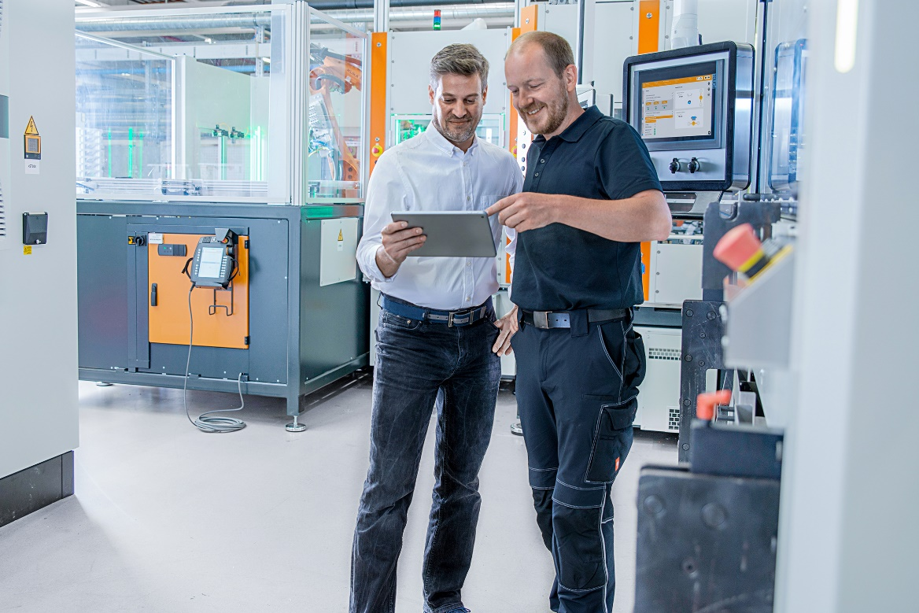
Image caption: PROCON-Connect enables users to easily capture machine data, pre-process it and make it available to other applications

The Weidmüller Group
Smart Industrial Connectivity: Electrification, automation, digitalisation, electrical connectivity, electromobility and renewable energies – markets in which Weidmüller feels right at home. The family-owned company established in 1850 has production facilities and sales companies in over 80 countries. As a global player in electric connection technology, Weidmüller achieved a turnover of more than one billion euros in the 2023 financial year with around 6,000 employees worldwide - around 2,000 of whom work at the company's headquarters in Detmold, in the heart of East Westphalia-Lippe, Germany. What Weidmüller lives by: Diversity with respect.
Technologies and engagement for a liveable future - Weidmüller demonstrates how it approaches the topic of sustainability in its interactive sustainability brochure.

Your contact person: Weidmüller Corporate Communications
Tel.: +49 5231 14-292322
Email: presse@weidmueller.com

