VARITECTOR AC BS60 – Surge protection for 60 mm busbar systems
Powerful lightning and surge protection is crucial to ensure system availability in buildings, industrial plants and power plants. The components protect increasingly sensitive infrastructures from costly failures and, in many areas, are even mandatory. With the VARITECTOR AC BS60, Weidmüller has expanded its portfolio to include lightning and surge protection components for 60 mm busbar systems.

Low space requirement and high flexibility on 60 mm busbars
The components of the VPU AC BS60 series are snapped tool-free onto the 60 mm busbar and are extremely compact, with a width of just 36 mm (2 TE division units on the busbar). They protect electronic components and devices in larger distribution cabinets and are tested in accordance with the valid IEC/EN 61643-11. The module consists of two components: the adapter to the busbar system and the pluggable surge protection arresters. The contact to the busbar can also be configured for different busbar widths and thicknesses. Both type I+II+III and type II+III arresters are available for the standard TN-C, TN-S and TT network types. In addition to the standard variant, the type I arresters with 12.5 kA discharge current are also available as a leakage current-free variant with LCF technology. The type II product configurations are also available as variants with an integrated fuse. The particular advantage of the integrated fuse is obvious: no additional NH back-up fuse is required upstream of the surge protection, especially for higher currents. The VPU AC II BS60 with integrated fuse saves additional installation space, installation effort and costs.

Easy installation and maintenance-friendly operation
Another advantage is the pluggability of the VPU AC arresters. In the event of maintenance, they enable easy and safe replacement without having to remove the entire device. The arresters also have a clearly visible status window and a pluggable remote signalling contact for reporting failures to the higher-level controller.
2,068 characters including spaces

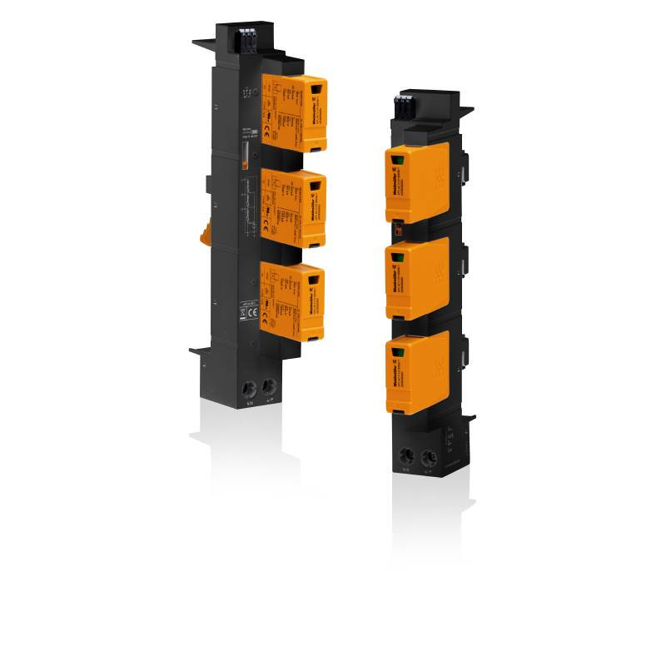
Image caption: VARITECTOR AC BS60 – compact lightning and surge protection for 60 mm busbar systems

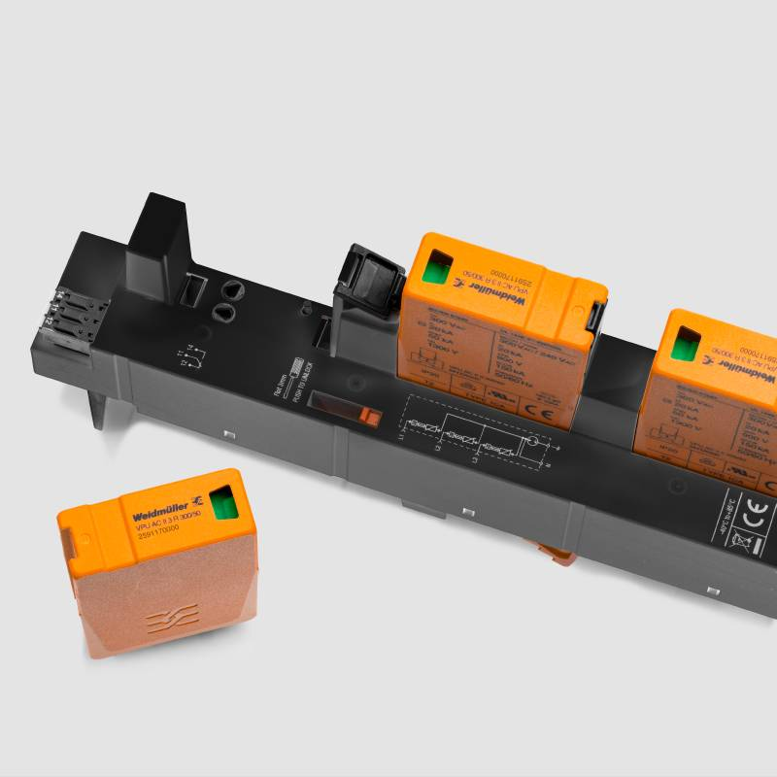
Image caption: Pluggable arresters enable easy and fast replacement in the event of maintenance

You are free to use all images. We request that you cite the image source.

The Weidmüller Group
Smart Industrial Connectivity: Electrification, automation, digitalisation, electrical connectivity, electromobility and renewable energies – these are markets in which Weidmüller feels right at home. The family-owned company established in 1850 has production facilities and distributors in over 80 countries. As a global player in electrical connectivity, in 2023 Weidmüller reported revenue in excess of one billion euros with around 6,000 employees worldwide – approx. 2,000 of whom are located at the headquarters in Detmold in the heart of Ostwestfalen-Lippe, Germany. Values Weidmüller lives by: Diversity with respect.

Technologies and engagement for a liveable future – Weidmüller demonstrates how it approaches the topic of sustainability in its interactive sustainability brochure.

Contact:
Weidmüller Corporate Communications
Company Spokesperson, Sybille Hilker
Phone: +49 (0)5231 / 14-292322
Email: presse@weidmueller.com

