The little all-rounder
TERMSERIES-compact – vibration-proof universal relay with ultra-compact design

Universal relays are needed in numerous general applications in automation – and are therefore used in more and more industrial fields. To guarantee maximum plant availability, they also need to work reliably in environments subject to frequent vibration. At the same time, more compact modules that fit into flat switchgear cabinets are also needed. With TERMSERIES-compact, Weidmüller now presents literally a small revolution that meets both these requirements in impressive form – and can do much more besides.

The perfect addition to the TERMSERIES

Coupling relays and solid-state relays in the TERMSERIES family really are all-rounders. They are extremely popular and have been part of Weidmüller’s proven portfolio of Klippon® relays for many years. Now, to allow the benefits of the TERMSERIES to be used in even more applications, TERMSERIES-compact has been developed. “The complete modules have an enclosed design and are absolutely vibration-proof. Thanks to their small depth of just 63 mm, they can even be installed in flat switchgear cabinets or terminal boxes,” says Dennis Harland, Head of Product Management Relays at Weidmüller, listing the advantages. “Users also benefit from the modules having the same contours as those in the TERMSERIES. This means that all the accessories can be used together. The mirror-symmetrical design and continuous cross-connection channels at every connection level are another advantage that allows highly flexible solutions to be implemented extremely efficiently and with short wiring times.”

Broad range of uses and high user-friendliness

Its many different versions make TERMSERIES-compact a real all-round genius. Designs with one NO contact and one changeover contact, with electromechanical relays and with variety of different input voltages enable a wide range of applications. A particular highlight is the TERMSERIES multi-voltage input with 24-230 V UC, which is also available for the TERMSERIES-compact in a space-saving version with 12-60 V UC. PUSH IN connections and coloured voltage inputs ensure fast, error-free wiring. “Each model is 100% function tested and checked for dielectric strength of the inputs and outputs. That guarantees safe operation,” says Harland emphatically. “Maintenance teams will be delighted with the easy-to-read article numbers and integrated test points at every level – and with the easy-to-see conductor labelling, the large coloured pushers and the bright status LEDs. It all makes day-to-day work easier and allows function tests at a glance.”

Digital support from planning to documentation

The provision of all data for WMC, Eplan, CAD and ITB texts in line with E-Class and ETIM standards is the ideal support for many planning and documentation processes and the creation of digital twins. Anyone who wants information about a product right there and then will appreciate the QR code on the side of the enclosure. “It is linked directly to the data sheet in the Weidmüller online catalogue, which provides all product information. A practical detail that saves a lot of time in everyday work and makes follow-up orders easier,” explains Harland.

Additional product versions and matching accessories

From the very beginning, TERMSERIES-compact is also available with an integrated fuse carrier. In case of malfunction, the fuse switches off individual conductive paths in order to protect the rest of the system and increase availability. The integration saves on additional series terminals with fuses. To make day-to-day work even more efficient, special accessories have been developed for TERMSERIES-compact. These complement the compatible range of accessories for TERMSERIES and include special supply terminals, feed-though terminals and partitions. “The accessories increase flexibility, simplify wiring and make structured integration and the separation of different voltage ranges easier,” says Harland, describing the benefits.

A small revolution that quickly pays off

With TERMSERIES-compact, Weidmüller has added a space-saving version to the proven TERMSERIES and proved once again how strongly the company focuses on the day-to-day requirements of its users. Thought out to the very last detail, the construction supports all processes, from initial planning to maintenance. Work becomes simpler, faster, safer and all-round more efficient.

4,458 characters including spaces

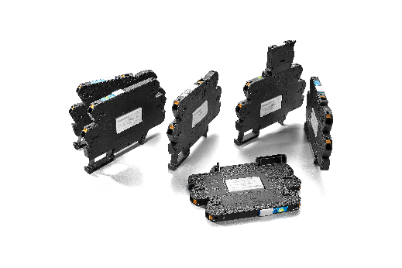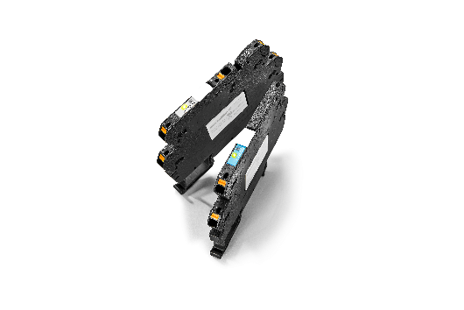
Image caption: TERMSERIES-compact complements the proven TERMSERIES from Weidmüller.
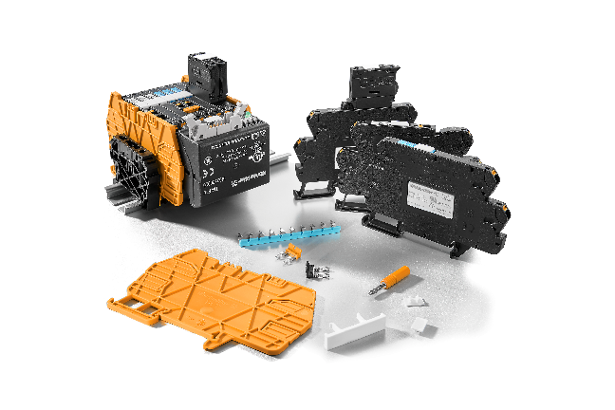

Image caption: The compact universal relays impress decision-makers, planners and users with a surprising number of ingenious details.

Your contact person: Weidmüller Corporate Communications
Tel. +49 (0) 5231 / 14-292322
Email: presse@weidmueller.com

Weidmüller – your partner in industrial connectivity.
The Weidmüller Group has production facilities, marketing companies and representative offices in more than 80 countries. With our customers, we shape the digital transformation – with products, solutions and services for Smart Industrial Connectivity and the Industrial Internet of Things. In the fiscal year of 2021, Weidmüller reached sales of 960 million euros with around 5,300 employees.

Responsible for content: Weidmüller Corporate Communications
Corporate Spokesperson, Sybille Hilker

