26 junior staff members celebrate their graduation
Apprentices and dual study programme students from Weidmüller receive their diplomas

Detmold, 3 March 2022. 19 apprentices and seven dual study students are beaming - they are proud to have successfully completed their training at Weidmüller. These junior staff members at the Detmold electronics specialist celebrated receiving their diplomas – while observing pandemic regulations. From tool and industrial mechanics to mechatronics engineers and system and equipment electricians – the graduates all received impressively high grades. “It is remarkable how well our apprentices and students have developed on a professional level and prepared themselves for their careers. They not only had to complete a wide range of professional duties, but also manage challenges related to the coronavirus” said Andreas Grieger, Head of Global Human Resources at Weidmüller, praising the group.

All of the graduates will continue working for Weidmüller. “The training is an important element of our corporate philosophy. We not only consider it part of our social responsibility as a mid-sized family-owned company, but it also lays the foundation for growth with young, motivated employees from the region” emphasises Chief Financial Officer André Sombecki. He says it is a major advantage to keep their knowledge and commitment within the enterprise. In addition, the entire company benefits from the new ideas and perspectives of the young colleagues.

The next group of trainees will begin their education in the summer, when 39 apprentices and twelve dual studies students will start their careers. With 131 apprentices and dual study programme students currently, Weidmüller is already one of the largest training enterprises in the region.

1,788 characters including spaces

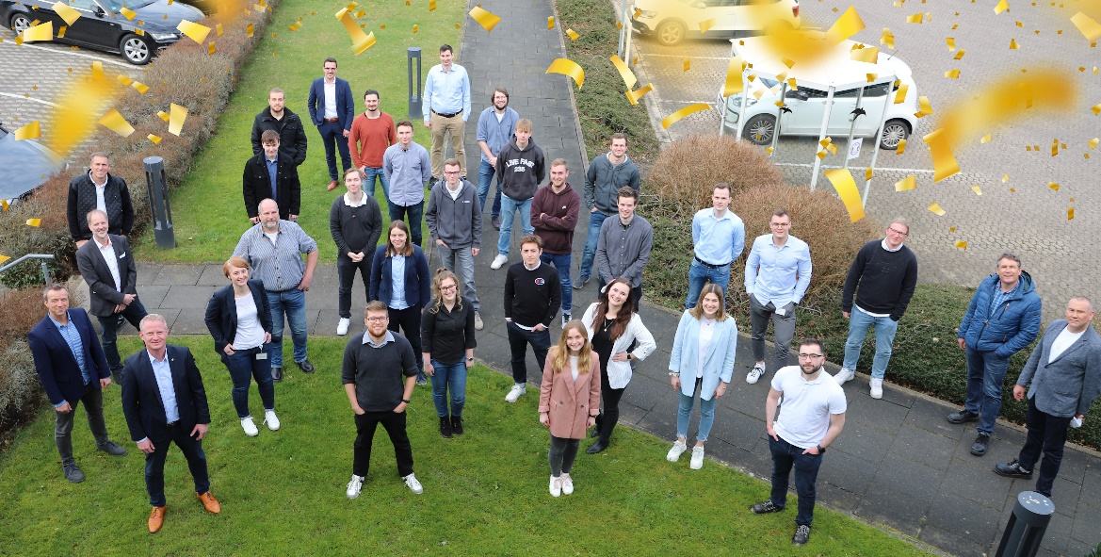
Apprentices and students celebrate their graduation alongside their mentors and managers at Weidmüller.

Your contact: Erol Kamisli
Tel.: +49 (0)5231 / 14-292322
E-Mail: presse@weidmueller.com

Weidmüller – a partner for Industrial Connectivity
The Weidmüller Group has production facilities, sales companies and representatives in more than 80 countries. Together with our customers, we shape the digital transformation – with products, solutions and services for Smart Industrial Connectivity and the Industrial Internet of Things. In the 2020 financial year, Weidmüller generated sales of €792 million with around 5,000 employees.

Responsible for the content Weidmüller Corporate Communications
Corporate Spokesperson, Sybille Hilker

