Clear insight into energy management: data scrubbing with regression analyses

Weidmüller makes it possible to harmonise energy management KPIs

Regression and correlation analysis for the ResMa® energy management system expands possibilities for energy managers. The supplementary tool scrubs data and harmonises KPIs. With the expansion module, companies can operate their energy management systems in accordance with ISO 50006 and meet the specifications of the EU corporate sustainability reporting guidelines (CSRD).

Dependencies lead to false conclusions – not with ResMa®!

Especially in terms of energy management, it is particularly interesting to find out how much energy purchasing a new system will save. However, when measuring energy consumption, data can often depend on external circumstances. In the case of a heating and air conditioning system, for instance, this could look as follows: during a particularly hot summer, the energy manager determines that the system is using an above-average amount of current. New equipment could lead to potential savings. Because of this, he exchanges the old system for a new one during the winter. The following summer, however, the temperatures are not as expected. The weather is cooler than in the previous year. The new air conditioning and heating system uses less energy due to the lower temperatures. How can the energy manager prove that the investment has paid off?

This is where regression and correlation analysis in ResMa® comes in: the system harmonises data collected from the previous year with data from the current one. This means data can be compared regardless of variable temperatures. In this way, the program can show the effective savings the heating and air conditioning system has delivered.

Creating regression models in just a few steps

The first step to creating a regression model is a correlation analysis. Users use the data collected in ResMa® to find correlations between individual values. In doing so, users can identify dependencies between, for example, hours of sunlight, daily maximum temperatures, work hours, and the power consumed by the heating and air conditioning system.
The focus is on the quality of these correlations. Correlation analysis calculations carried out by ResMa® deliver results in the range between +1 and -1. The closer a value is to +1, the stronger the dependency is. If the value approaches -1, on the other hand, this represents a negative interdependency. If the system shows a result around 0, there is no dependency between the values investigated.

Once the energy manager has identified dependencies between the values and determined the type of correlation, they can create a regression model. The model automatically calculates the data and transmits the harmonised results. Now, the data can be compared and values can be drawn from the system regardless of other measured values.
Implementing a regression analysis requires no data science expertise. The expansion module specifies the exact steps for users to create models, helping them to implement use cases.

In addition to energy management, regression analyses can also be used for troubleshooting in production. The regression analysis can use an error in the quality of the final product, for example, to identify a correlation to a known irregularity or other data. In addition, increased energy consumption can help identify incorrect machine settings or a system defect.

Energy management in accordance with ISO 50001 and ISO 50006

Energy management is becoming a more and more important focus for companies. Driven by new EU guidelines, especially the CSRD, companies are now obligated to provide precise information on their energy usage. The energy and resource management tool ResMa® facilitates energy management according to ISO 50001 and meets EU specifications. The regression analysis tool adds energy management according to ISO 50006 to ResMa®. ResMa® and the regression analysis tool make it possible for companies to plan for the future and prepare optimally for future legal requirements.
Weidmüller offers a comprehensive energy management portfolio. In addition to the ResMa® software and regression analysis, the solution includes a variety of hardware products: energy meters, as well as the improved energy measurement module for the I/O system u-remote.

4356 characters including spaces

Image source: Weidmüller

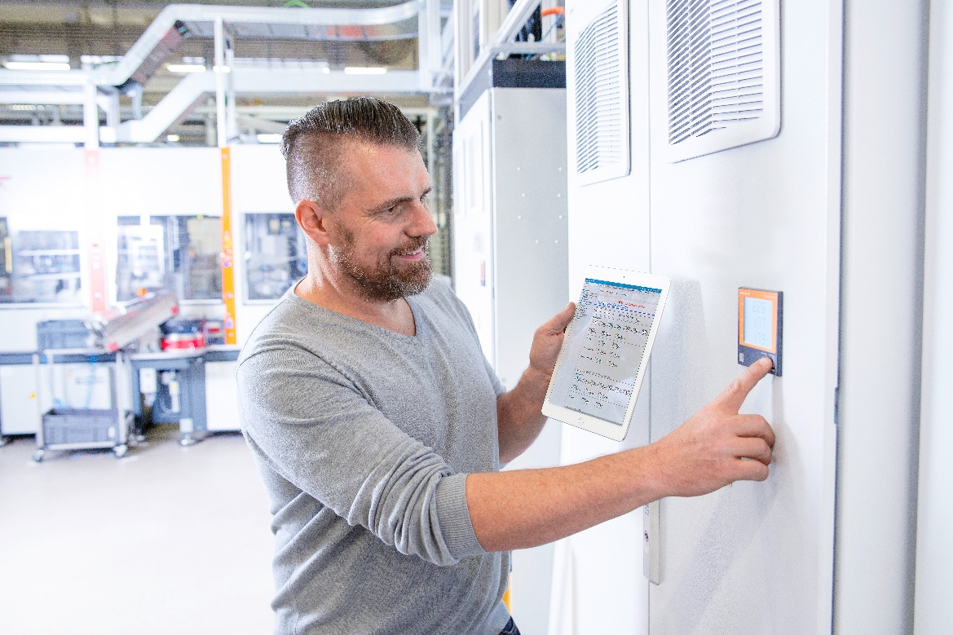
Image Caption: A regression analysis provides a precise overview of system energy consumption – regardless of external influences

The Weidmüller Group
Smart Industrial Connectivity: Electrification, automation, digitalisation, electrical connectivity, electromobility and renewable energies – markets in which Weidmüller feels right at home. The family-owned company established in 1850 has production facilities and sales companies in over 80 countries. As a global player in electric connection technology, Weidmüller achieved a turnover of more than one billion euros in the 2023 financial year with around 6,000 employees worldwide - around 2,000 of whom work at the company's headquarters in Detmold, in the heart of East Westphalia-Lippe, Germany. What Weidmüller lives by: Diversity with respect.
Technologies and engagement for a liveable future - Weidmüller demonstrates how it approaches the topic of sustainability in its interactive sustainability brochure.

Your contact person: Weidmüller Corporate Communications
Tel.: +49 5231 14-292322
Email: presse@weidmueller.com

