Digital cabinet building with a clear efficiency edge
How the new Online Weidmüller Configurator reduces costs and eases the pressure of the skilled labour shortage

Industry is under pressure: the shortage of skilled workers is a reality, while expectations for efficiency and digital connectivity continue to rise. Cabinet building in particular requires solutions that simplify processes and reduce costs. This is exactly where the new Online Weidmüller Configurator comes in.

Developed with and for users
The Online Weidmüller Configurator was developed in close cooperation with users from industry and the field. The goal was to create a digital tool that addresses real challenges in day-to-day planning and engineering – one that is intuitive, efficient and practice-oriented. “We wanted to make a tool that wasn’t just impressive in theory, but also offered real added value in everyday use”, explains Andrés Lavid de las Heras, Product Manager at Weidmüller.

Seamless digital processes and flexible assembly
From planning through to production, the new Configurator ensures a continuous digital chain. Rail configurations can be created directly in any browser, stored in the cloud and shared via links – any time, anywhere. As a fully web-based tool, the Configurator can be used on any device with internet access, whether notebook, tablet or smartphone. Users can use it either via touch screen or with the traditional mouse and keyboard. Existing configurations from the well-known Weidmüller Configurator (WMC) can also be transferred directly via cloud upload, ensuring a seamless transition and uninterrupted workflows. This reduces media disruptions, minimises errors and saves time.
A central function of the new Online Weidmüller Configurator is the integrated assembly assistant. It guides users very easily step by step through the assembly and placement of components, enabling simple and reliable assembly – anyone can do it – no electrical background needed. This helps to reduce the industry’s dependency on highly qualified personnel, which is particularly relevant given the growing shortage of skilled workers.
In addition, the Configurator allows users to order fully assembled terminal strips directly from Weidmüller. Through the Fast Delivery Service (FDS), configured terminal strips can be requested online. Individual quotations are generated rapidly, resulting in accelerated assembly planning for maximum speed – enabling fast, flexible and efficient execution of production processes.

Automatic Optimisation – Just One Click Away
Achieve high efficiency thanks to smart optimisation functions in cabinet building. The new Configurator simplifies the configuration of rails. Thanks to its intelligent optimisation functions, the tool automatically makes the best possible use of the available space on the rail – without requiring in-depth product knowledge. With a single click, connection technologies can be switched to more production-efficient variants, such as PUSH IN or SNAP IN. This reduces assembly times, lowers costs and ensures streamlined planning and production throughout. This makes cabinet building simpler, faster and more economical.

Digitalisation as a response to current challenges
The new Online Weidmüller Configurator shows how digital solutions boost efficiency in cabinet building while easing the burden on skilled personnel. With intuitive operation, smart automation and seamless data availability, it becomes a key driver for process optimisation in modern production environments.
The solution forms part of Weidmüller’s practice-oriented overall concept: M-Print® PRO software enables efficient marking, while the Wire Processing Center (WPC) supports semi-automated cable assembly and the Labelling Processing Center (LPC) provides automated component labelling. These elements support the entire process chain – from planning and configuration through to production. They work together seamlessly to ensure maximum efficiency in cabinet building.

4,006 characters including spaces

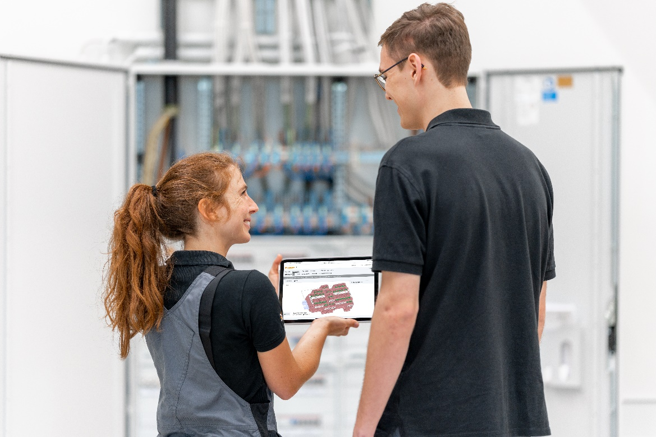
Image caption: From planning and configuration through to production, the new Online Weidmüller Configurator ensures a continuous digital data chain.

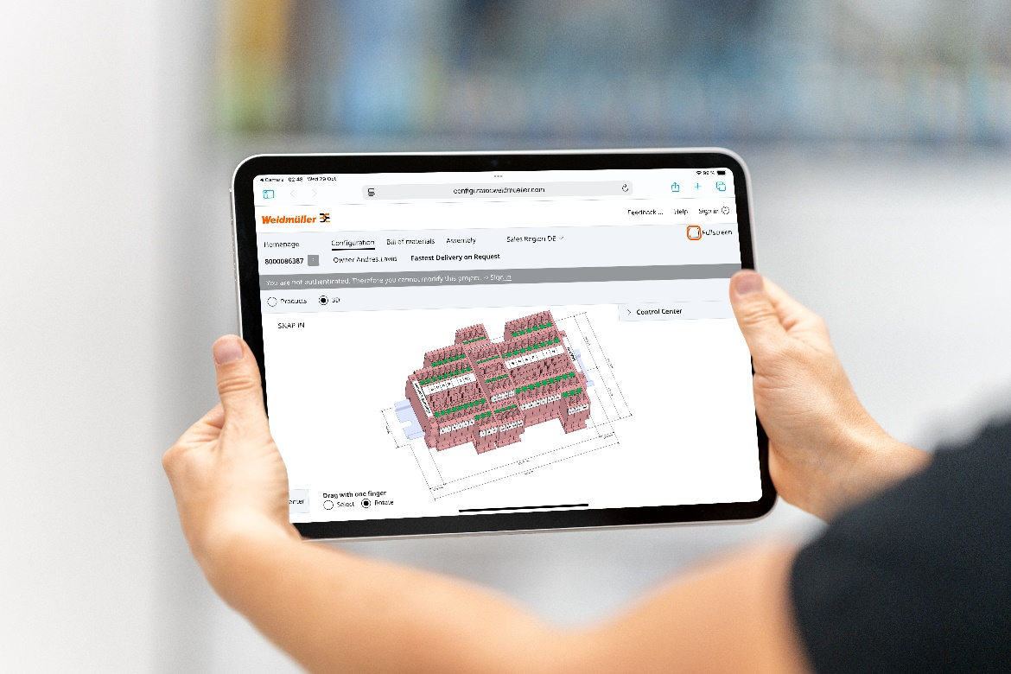
Image caption: High efficiency thanks to smart optimisation functions in cabinet building.

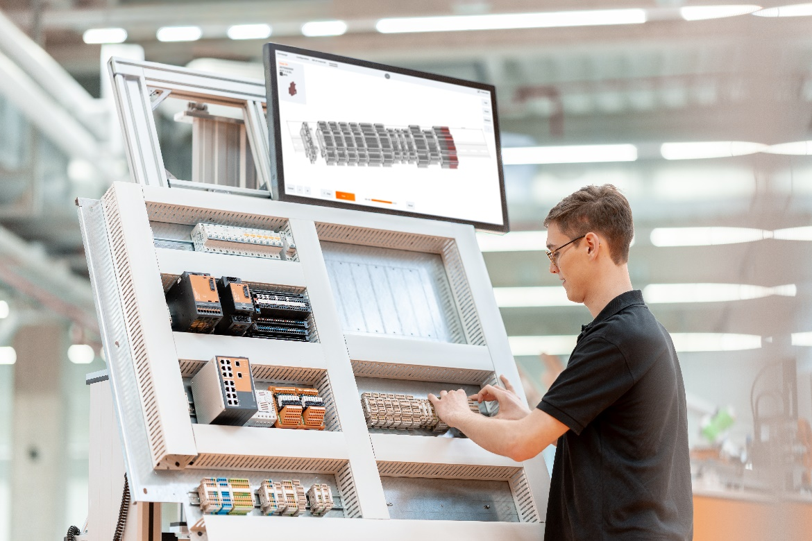
Image caption: Efficient terminal strip assembly in production with the help of the Online Weidmüller Configurator.

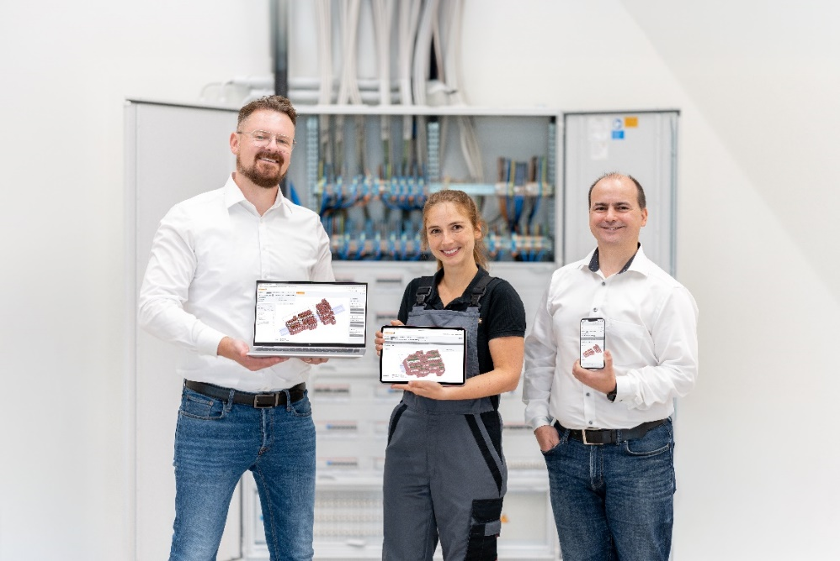
Image caption: The Online Weidmüller Configurator is fully web-based and can be used on any device with internet access – whether notebook, tablet or smartphone.

You are free to use all images. You can download them from the following link: Weidmüller Pressemitteilung_Online Weidmüller Configurator

The Weidmüller Group
Industrial Connectivity: Electrification, automation, digitalisation, electrical connectivity and renewable energies – markets where Weidmüller feels right at home. Established in 1850, the family-owned company is represented in over 80 countries with its own production sites and sales companies. As a global player in electrical connectivity, Weidmüller achieved a turnover of almost one billion euros in the 2024 financial year with around 5,700 employees worldwide – about 2,000 of them based at the company’s headquarters in Detmold, in the heart of the East Westphalia-Lippe region of Germany. In all its activities, Weidmüller promotes diversity and respect.

Technologies for and commitment to a liveable future – Weidmüller demonstrates how it approaches the topic of sustainability in its interactive sustainability brochure.

Contact:
Weidmüller Corporate Communications
Marc Landermann, Head of Corporate Communications
Tel.: +49 (0)5231 / 14-292322
Email: presse@weidmueller.com

