Make more of Raspberry Pi: “u-maker Box” housing – modular and simple, with a great design
Weidmüller is expanding its product line of electronic housings for industrial use with the “u-maker Box” Raspberry Pi housing. Specially developed for private use, the housing can also be used in industrial switch cabinets. From modular to small or profile housing, the new, customisable enclosure system for the Raspberry Pi 4 impresses users with excellent flexibility, simplicity and a modern and user-oriented design.

Professional Raspberry Pi housing from renowned automation solutions provider Weidmüller
Makers and do-it-yourself specialists worldwide are turning their ideas into reality with the Raspberry Pi mini single board computer. Its wide range of applications range from simple automation solutions in a smart home to custom arcade games. However, as a project becomes more complex, requirements for the housing also increase. It needs to be suitable for custom extension and be able to grow with the maker's projects.
The u-maker Box offers more than just simple protection of sensitive electronics. The modular design allows for flexible adaptation, so that makers can create their projects regardless of their complexity. The housing is compatible with ActionCam accessories, facilitating a broad spectrum of custom modification options. In addition, the u-maker Box offers space to integrate supplementary boards. Do-it-yourself makers can expand the functions of their mini single board computer with the “u-maker Box” Raspberry Pi 4 housing, in order to take full advantage of the board’s potential. The extension from Weidmüller software even makes the u-maker Box interesting for programmers.

“u-maker Box” Raspberry Pi housing offers multiple advantages
The u-maker Box combines an appealing design with user benefits. Users can adapt the u-maker Box to fit their needs. Designed for makers, the u-maker Box impresses with its simple and dynamic design, that integrates well into the user’s home.
The black plastic housing is based on a modular principle and is completely flexible. An extension kit supplements the u-maker Box base kit. It contains an extended module and plug-in accessories. These make it possible to attach different elements such as boards, cables, fans, and other electronic components.
A special feature of the u-maker Box is that it can be expanded floor by floor. The housing can be structured on different levels. The individual levels can be filled with different components, such as other boards. The u-maker Box is not restricted to Raspberry Pi 4; boards from third-party providers can also be easily integrated. The cube shape of the housing also offers space for an 80mm fan. These are more powerful and quieter than smaller variants, making them ideal for home use.
Thanks to the many different functions and options it offers, the u-maker Box is guaranteed to be easy to use. The Raspberry Pi housing is configurable tool-free and can be assembled directly and easily by users. Neodymium magnets hold all of the modules together, from the housing cover to the base. The powerful magnets ensure a consistent, long-term connection between the individual components. In addition, the u-maker Box can be fastened with standard screws. The components are secured inside the box by simply plugging them in. This allows makers to easily make changes in the box without tools. Assembly of the u-maker Box is simple and flexible. Thanks to its many years of experience in electronic housings, Weidmüller has created an optimal Raspberry Pi housing for do-it-yourself specialists and makers.

Pi housing with templates for 3D printing
Weidmüller offers 3D printing templates for its u-maker Box. The electronics company makes these freely available on the Thingiverse platform. From there, they can easily be downloaded and printed out directly on a 3D printer. The templates contain patterns that expand the horizon of applications for Raspberry Pi. From holders for electronics to assembly aids to frame inserts for touch-capable screens, the printing templates offer inspiration for many different applications. They also offer the option of modifying and adjusting the templates to fit the user’s own needs. This allows users to combine accessories of many different types and from many different providers with the u-maker Box. In doing so, makers can use their existing materials for installation without having to purchase new components. The printing templates allow users to take advantage of the full potential of the u-maker Box and adapt it to their applications.

“u-OS” open operating system for Raspberry Pi
As a partner for Smart Industrial Connectivity, Weidmüller offers a variety of solutions in Industrial IoT and automation. The Raspberry Pi 4 can be expanded seamlessly with the new, open u-OS operating system from the electronics company. From data mining to data aquisition, to pre-processing and communication, u-OS supports industry as well as private use. The expandable, web-based system can be easily adapted to the user’s individual needs, even without programming expertise.
Weidmüller is producing the u-maker Box as a housing for Raspberry Pi 4 that is as versatile as the needs of its users. The modern and modular design of the u-maker Box supports simple handling and diverse applications, offering outstanding function which allows users to implement their own ideas.

5,451 characters including spaces

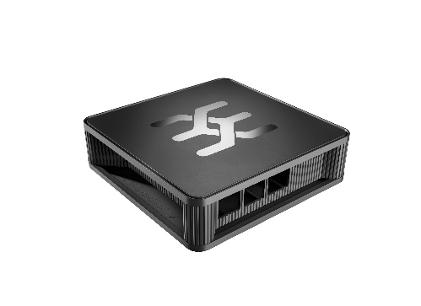

Image caption: The modular and dynamic housing for the Raspberry Pi 4: The u-maker Box.

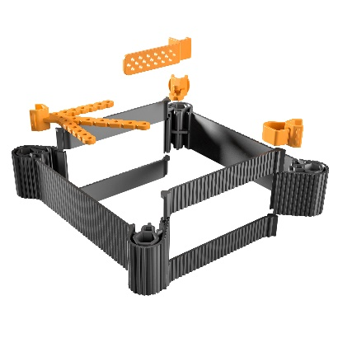
Image caption: With the Extension Kit, the u-maker box can be extended on several levels.

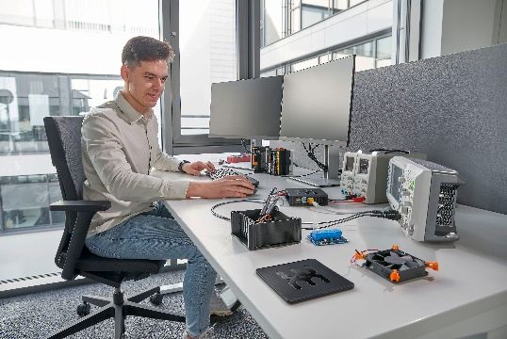

Image caption: The u-maker box can be used in many ways. In development as well as in the smart home.

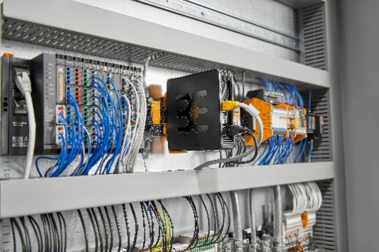
Image caption: The housing for the Raspberry Pi 4 is also used in the control cabinet.

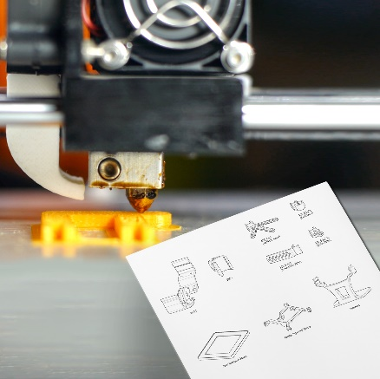
Image caption: With the 3D print templates, brackets can be created comfortably at home.

Your contact person: Weidmüller Corporate Communications
Tel.: +49 5231 14-292322
Email: presse@weidmueller.com

Weidmüller - Your Partner in Smart Industrial Connectivity
The Weidmüller Group has production facilities, marketing companies and representative offices in over 80 countries. Alongside its customers, the family-owned company from Detmold is shaping the digital transformation – with products, solutions and services for Smart Industrial Connectivity and the Industrial Internet of Things. In the 2022 financial year, Weidmüller generated sales of more than a billion euros with around 6,000 employees.

Responsible for the content: Weidmüller Corporate Communications
Corporate Spokesperson, Sybille Hilker

