Strong winds, strong partnership
Weidmüller and Turbit expand their collaboration

Weidmüller and Turbit are intensifying their partnership to provide advanced monitoring and analysis services for wind turbine operators and owners. This collaboration incorporates Weidmüller's extensive expertise in rotor blade monitoring with Turbit's pioneering AI-based data analysis, aiming to enhance the efficiency and cost-effectiveness of wind turbine operation and maintenance.

The electronics and connectivity company Weidmüller, with over 20 years of experience in wind turbine condition monitoring, provides data specifically targeting the behaviour and condition of rotor blades. "Our condition monitoring system, BLADEcontrol®, enables wind farm managers to significantly increase their equipment availability while markedly reducing downtime," states Daniel Schingnitz, Head of Sales & Marketing at Weidmüller Monitoring Systems.

The Berlin-based technology company Turbit specialises in software products for the monitoring of wind turbine operational data. By employing artificial intelligence, Turbit analyses data from various system components, identifying anomalies in operational behaviour. This information is provided to customers—typically operators and owners of wind turbines—to facilitate preventive maintenance measures and avoid potential damages.

Rotor blade monitoring meets AI

The partnership between Weidmüller and Turbit enables the generation of even more comprehensive diagnostics for wind turbines. "Weidmüller supplies us with highly qualified data regarding rotor blades, which we analyse to identify deviations from normal blade behaviour at an early stage. Our collaboration allows our customers to address these anomalies before major damages occur," explains Christian Fontius, Co-Founder and CCO of Turbit.

"By collaborating with Turbit, we can integrate our rotor blade monitoring data into a more comprehensive monitoring system," adds Schingnitz. "This allows us to further qualify our data and draw more concrete conclusions from identified anomalies."

"This offers significant added value to our customers. With an increased level of monitoring, we can detect more damages, which greatly facilitates day-to-day operations and leads to a reduction in unplanned downtimes," Fontius elaborates.

A strong alliance for preventive maintenance

The efficiency of this collaboration has already been demonstrated in two pilot projects with 6MW-class wind turbines. Further projects are planned to promote the integration of the systems into even more wind farms. In parallel with their technical collaboration, Weidmüller and Turbit are enhancing their joint customer presence at several trade fairs, such as Hamburg Wind Energy, Wind Energy Days in Linstow, and in customer workshops. Through their combined expertise, the two companies offer even more comprehensive consulting services.

This cooperation represents a significant step towards more efficient and cost-effective wind turbine monitoring. Both companies are continuously working to optimise their systems and provide maximum value to their customers. Future plans include extending monitoring to additional wind parks.

3,200 characters including spaces

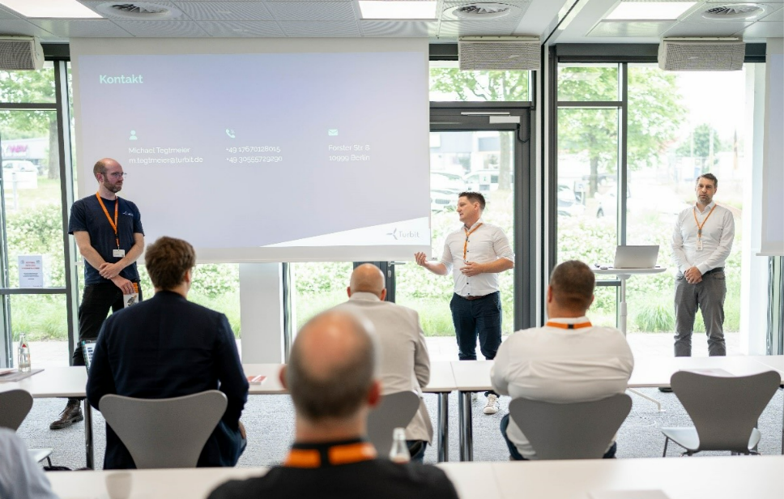
Image caption: Image caption: Turbit delivers keynote speech at Weidmüller’s Wind Energy Forum 2024 in Detmold, Germany (Speakers from left to right: Michael Tegtmeier, Managing Director of Turbit; Daniel Schingnitz, Head of Sales & Marketing at Weidmüller Monitoring Systems; Daniel Brenner, Head of Monitoring at Weidmüller Monitoring Systems)

You are free to use all images. We request that you cite the image source Weidmüller.

The Weidmüller Group
Smart Industrial Connectivity: Electrification, automation, digitalisation, electrical connectivity, electromobility and renewable energies – markets in which Weidmüller feels right at home. The family-owned company established in 1850 has production facilities and sales companies in over 80 countries. As a global player in electric connection technology, Weidmüller achieved a turnover of more than one billion euros in the 2023 financial year with around 6,000 employees worldwide - around 2,000 of whom work at the company's headquarters in Detmold, in the heart of East Westphalia-Lippe, Germany. What Weidmüller lives by: Diversity with respect
Technologies and engagement for a liveable future - Weidmüller demonstrates how it approaches the topic of sustainability in its interactive sustainability brochure.

Your contact person: Weidmüller Corporate Communications
Tel.: +49 5231 14-292322
Email: presse@weidmueller.com

