Press release 

Weidmüller wins Industry 4.0 Innovation Award
Automated Machine Learning Tool awarded prestigious prize

Detmold / Nuremberg, 27 November 2019. Electrical engineering company
Weidmüller has been presented with the Industry 4.0 Innovation Award for its
Automated Machine Learning Tool. Weidmüller Chief Technology Officer, Volker Bibelhausen, and Tobias Gaukstern, Head of Business Unit Industrial Analytics at Weidmüller, accepted the prize on 26 November at the Detmoldbased company's stand at the Smart Production Solutions trade show in
Nuremberg. “We are delighted that the jury and the community were won over by our innovative software solution and that we won this award by such a large margin,” explains Bibelhausen. “At this point, I would like to thank the entire
Analytics team and of course all the people who voted for our software.” The Industry 4.0 Innovation Award was advertised and awarded in 2019 for the fourth time by VDE VERLAG GmbH in collaboration with ZVEI and the Standardisation Council Industry 4.0.

To be accepted to compete in the award, the products and innovations must make both a profit-generating and a supporting contribution in connection with
Industry 4.0. “We are extremely delighted that Weidmüller won our Industry 4.0
Innovation Award in 2019 for its Automated Machine Learning Tool,” explains Ronald Heinze, Chief Editor of Open Automation and Head of Publishing of magazines. “Our publication wishes Weidmüller continued success with its award-winning solution to enable as many engineers and technicians as possible to use AI and ML-based models.”

With its Automated Machine Learning Tool, Weidmüller offers a software that domain experts can use to independently create ML models – without any special knowledge of Machine Learning (ML). “It is our vision to democratize the use of AI and ML in the industry with the Automated Machine Learning Tool. The vote confirms the need for easy to use ML solutions and gives us additional impetus for the further development,” adds Gaukstern.

1

Press release

1.923 characters including spaces
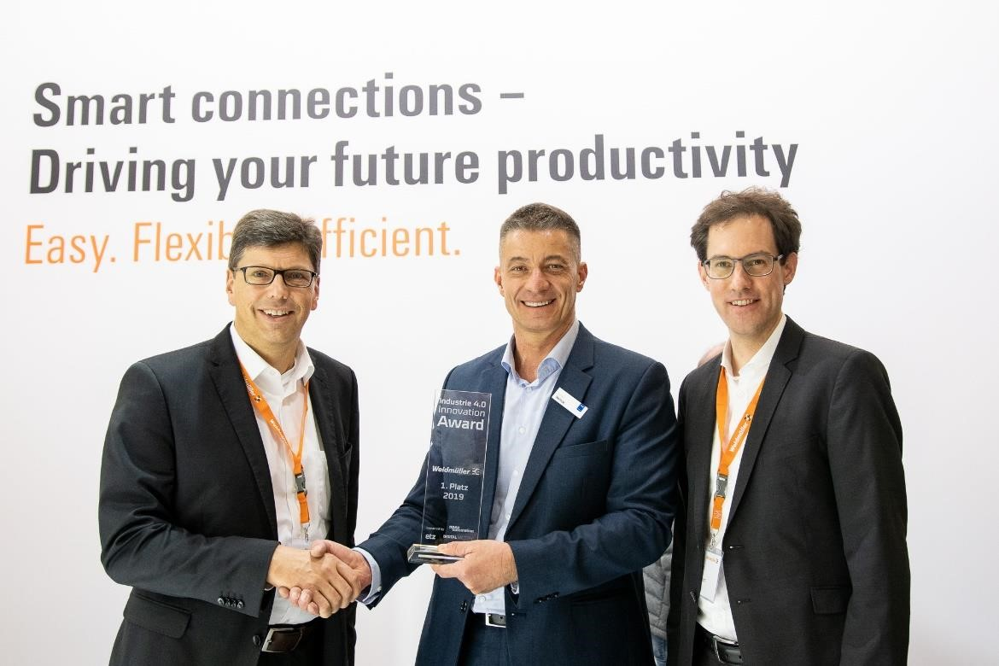
Image caption: Volker Bibelhausen (left) and Tobias Gaukstern (right) thankfully accepted the award at the fair smart production solutions from editor-in-chief Ronald Heinze (m.).

Weidmüller – your partner in industrial connectivity.
As experienced experts we support our customers and partners around the world with products, solutions and services in the industrial environment of power, signal and data. We are at home in their industries and markets and know the technological challenges of tomorrow. We are therefore continuously developing innovative, sustainable and useful solutions for their individual needs.
Together we set standards in Industrial Connectivity.
The Weidmüller Group owns manufacturing plants, sales companies and representatives in more than 80 countries.
In its fiscal year 2018 Weidmüller achieved sales of 823 million Euros with 4,900 employees.

Contact: Carsten Nagel
Corporate Communication
Tel.: +49 (0)5231 14291010
E-mail: carsten.nagel@weidmueller.com
2

