Weidmüller receives certification for industrial security

Weidmüller, the international electrical engineering and automation company, has been certified by TÜV Nord in accordance with the IEC 62443-4-1 standard for industrial IT security.

Weidmüller has received the certificate for industrial IT security according to IEC 62443-4-1 from TÜV Nord. IEC 62443 is the most important internationally recognised standard for IT security in automation and control systems. The certificate underlines Weidmüller's commitment to developing secure-by-design products. The aim is to enable customers to operate their machines and systems safely with secure-by-design products and to comply with legal security requirements such as the NIS2 Directive and the Cyber Resilience Act (CRA).

The networking of machines and systems in the Industrial IoT opens up new opportunities for businesses. It paves the way for applications such as machine learning, condition monitoring and predictive maintenance. However, new challenges are emerging as connectivity increases at the production level. Formerly isolated OT systems are increasingly connected to the IT infrastructure and the Internet, significantly increasing the threat of cyber-attacks. As a result, the cybersecurity of industrial systems is becoming critical to ensuring the continuity and efficiency of production.

The cybersecurity of a product is largely determined at the development stage. This is why Weidmüller has had its development process for hardware and software certified according to IEC 62443-4-1. A central component in the development of a Secure-by-Design product is the implementation of a threat and risk analysis based on the application scenario. The second step is to derive hardening measures for the product. The principles of secure design contribute to a defence-in-depth strategy for the product.

With the secure-by-design principle, Weidmüller focuses on the development process – and thus on the entire product lifecycle. This ensures that the products remain IT secure while in use at the customer.

With the new certification, Weidmüller certifies to its customers that cybersecurity determines a product from the beginning to the end of its life cycle. In addition, IEC 62443-4-1 is an important component for companies to successfully implement the CRA.

2330 characters including spaces

Image Source: Weidmüller

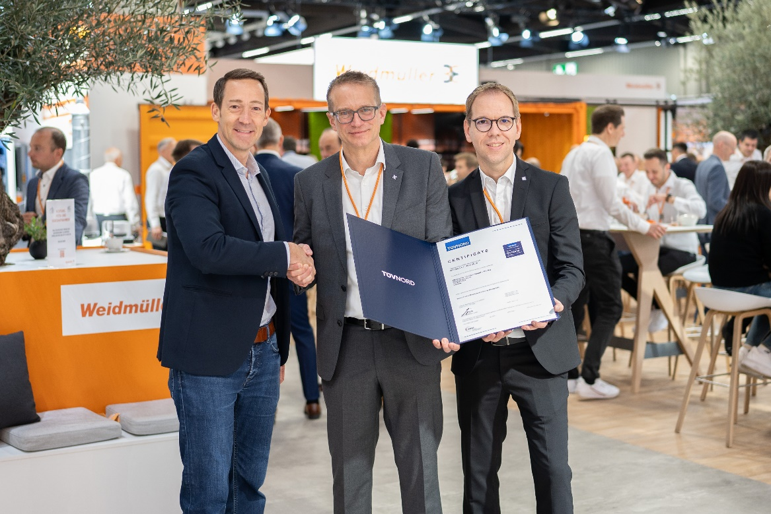
Image caption: f.l.t.r. Matthias Springer, Head of Functional Safety & Security at TÜV NORD CERT hands the certificate to Dr. Thomas Bürger, Executive Vice President Automation Products and Solutions at Weidmüller und Dr. Björn Griese, Head of Product Security bei Weidmüller

The Weidmüller Group
Smart Industrial Connectivity: Electrification, automation, digitalisation, electrical connectivity, electromobility and renewable energies – markets in which Weidmüller feels right at home. The family-owned company established in 1850 has production facilities and sales companies in over 80 countries. As a global player in electric connection technology, Weidmüller achieved a turnover of more than one billion euros in the 2023 financial year with around 6,000 employees worldwide - around 2,000 of whom work at the company's headquarters in Detmold, in the heart of East Westphalia-Lippe, Germany. What Weidmüller lives by: Diversity with respect.
Technologies and engagement for a liveable future - Weidmüller demonstrates how it approaches the topic of sustainability in its interactive sustainability brochure.

Your contact person: Weidmüller Corporate Communications
Tel.: +49 5231 14-292322
Email: presse@weidmueller.com

