CUBESERIES industrial relay modules made in Europe
Weidmüller extends its universal range of relay modules

Universal relays are essential in many general automation applications and are therefore increasingly being used in various industrial sectors. With the CUBESERIES, Weidmüller is extending its universal range of relay modules. Manufactured in Europe, these relay modules are the ideal solution for switching small loads, decoupling system parts and multiplying signals in machine engineering as well as in process and energy technology. The CUBESERIES portfolio includes various contact designs, variants with PUSH IN and screw connections, as well as a wide range of accessories, such as cross-connections, LED modules and protection modules.

Comprehensive product line
The industrial relay modules impress with their versatility and their availability in different widths and contact designs. From a width of just 15.6 mm, they are available with 1 CO contact (16 A) or 2 CO contacts (8 A). From a width of 27 mm, the range also offers variants with 2 CO contacts (12 A) and 4 CO contacts (7 A). Users can also choose between the innovative PUSH IN connection technology and conventional screw connections.
A wide range of accessories makes the relays an ideal solution for demanding applications: metal retaining clips ensure a secure hold in high-vibration environments, LED modules with red and green status displays enable intuitive status monitoring and protection modules with RC filters and varistors ensure reliable functionality.
Thanks to international cURus and CSA approvals, the relay modules are also fully compatible with systems for the American and Canadian markets. They therefore offer maximum flexibility and performance for an extremely broad range of applications worldwide.

Sophisticated product design
Relay sockets with PUSH IN connections and the wide range of cross-connection options make wiring quick and easy. The PUSH IN connections can be used with industry-proven screwdrivers with a width of up to 5.5 mm, enabling rapid and efficient installation and maintenance. The lockable test buttons on the CUBESERIES offer a decisive advantage: they enable the precise simulation of digital input signals with colour coding for AC (orange) and DC (blue). This functionality allows a step-by-step, controlled inspection of machines and systems during commissioning and maintenance. In addition, the retaining clips are equipped with a marker holder that ensures seamless compatibility with Weidmüller’s MultiCard and MultiMark marking systems. This simplifies identification for increased organisation and efficiency in demanding applications.

2,671 characters including spaces

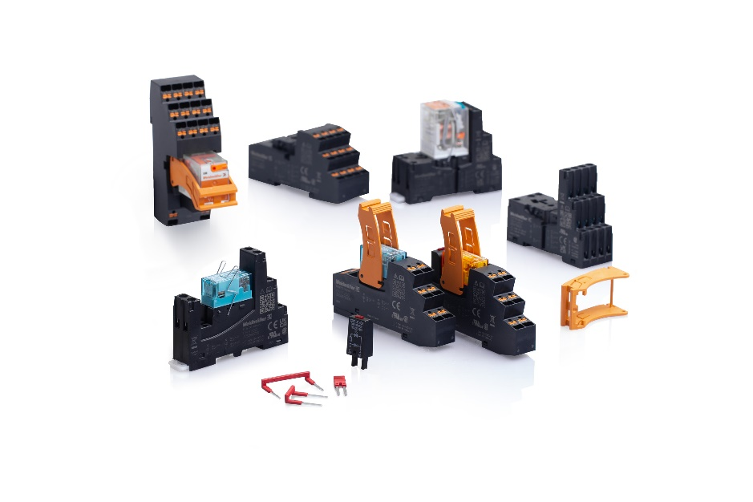
Image caption: The extensive product line of CUBESERIES industrial relay modules made in Europe impresses with its versatility and its availability in different widths and contact designs
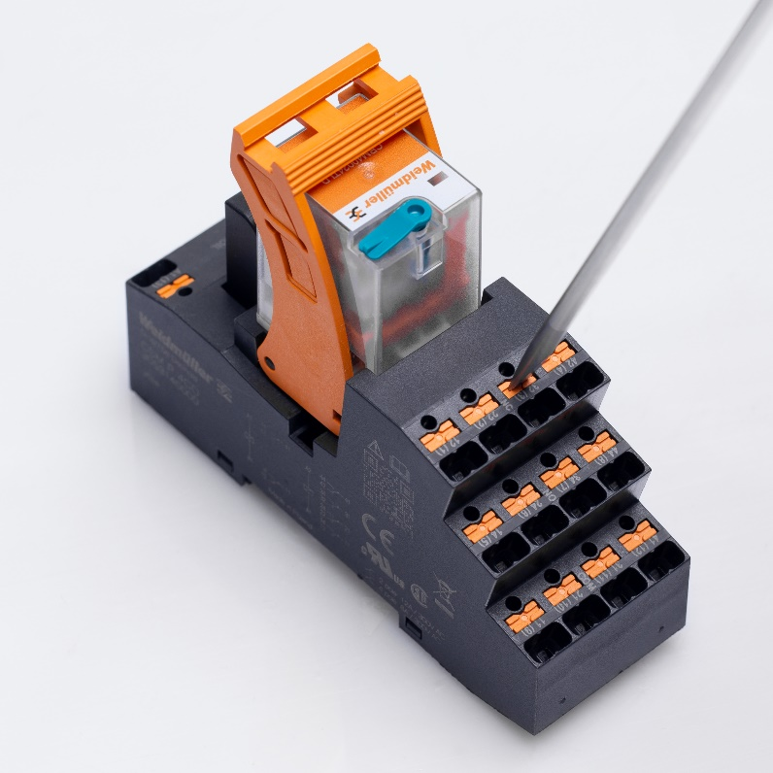

Image caption: Extension of the CUBESERIES: The PUSH IN connections can be used with industry-proven screwdrivers with a width of up to 5.5 mm

You are free to use all images. We request that you cite the image source.

The Weidmüller Group
Smart Industrial Connectivity: Electrification, automation, digitalisation, electrical connectivity, and renewable energies – these are markets in which Weidmüller feels right at home. The family-owned company established in 1850 has production facilities and distributors in over 80 countries. As a global player in electrical connectivity, in 2023 Weidmüller reported revenue in excess of one billion euros with around 6,000 employees worldwide – approx. 2,000 of whom are located at the headquarters in Detmold in the heart of Ostwestfalen-Lippe, Germany. Values Weidmüller lives by: Diversity with respect.

Technologies and engagement for a liveable future – Weidmüller demonstrates how it approaches the topic of sustainability in its interactive sustainability brochure.

Contact:
Weidmüller Corporate Communications
Tel.: +49 (0)5231 / 14-292322
Email: presse@weidmueller.com

