Weidmüller Group acquires the business of Emphatec Inc.
The Team and Capabilities of Emphatec will supplement the solutions portfolio of Klippon Engineering

Detmold / Markham (Ontario), 2 July 2021. Detmold-based electronics specialist Weidmüller continues its growth strategy for Process Automation Connectivity, Communication and Digitalization. With the acquisition of the team and assets of Emphatec Inc. the Weidmüller Group extends its portfolio, especially when it comes to PLC migration and C1D2 (Class 1 Division 2) solutions.

Emphatec and Weidmüller have had an extensive collaboration over decades. To further solidify this relationship and further reinforce Weidmüller’s organizational focus on the process industry, Weidmüller has completed the acquisition of the business and assets of Emphatec. Emphatec specialized in the engineering of customized connectivity solutions for the process industry, including hazardous areas. “It’s an ideal fit – Weidmüller’s global sales and marketing resources and extensive product offering alongside Emphatec’s innovative process automation focused products”, says Don Robinson, former owner Emphatec Inc., now Director of Klippon Engineering Canada.

Klippon Engineering was established by Weidmüller in 2021 and is responsible for a worldwide network of engineering and service expertise for the process industry. With its own sales team, application experts, affiliated production and assembly sites, product and application-specific solutions will be developed, certified and implemented in the future. "With our concentrated experience from six decades, we are at our customers' side as a competent partner in numerous areas of the process industry. We are strengthening our commitment in a growth market, in keeping with our tradition and history, and are positioning ourselves for future requirements", Dr Timo Berger, Chief Sales Officer of the Weidmüller Group, is pleased to say.

“Our customers can benefit from a new global competence center as an extension of the large range portfolio of Klippon Engineering. We are proud to finally call the former Emphatec experts our team members now.“, explains Jonathan Lane, Managing Director Klippon Engineering UK Ltd.

We are confident that the acquisition will push Weidmüller’s market position and business even further and are looking forward to a continuous trustful cooperation with our business partners.

The Klippon Engineering team in Markham, Ontario, formerly Emphatec Inc.

Don Robinson, Director of Klippon Engineering Canada
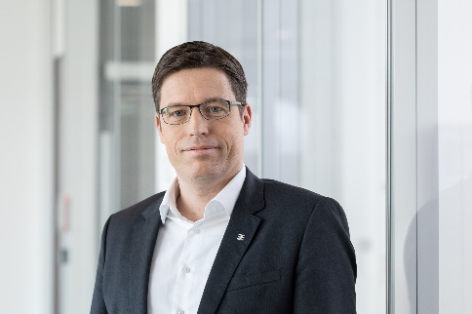
Dr Timo Berger, Chief Sales Officer

Jonathan Lane, Managing Director Klippon Engineering

Weidmüller – a partner for Industrial Connectivity
The Weidmüller Group has production facilities, sales companies and representatives in more than 80 countries. Together with our customers, we shape the digital transformation – with products, solutions and services for Smart Industrial Connectivity and the Industrial Internet of Things. In the 2019 financial year, Weidmüller generated sales of €830 million with around 5,000 employees.

Contact: Weidmüller Corporate Communications
Corporate Spokesperson Sybille Hilker
Tel.: +49 5231/14-292322
E-Mail: presse@weidmueller.com

