Networking down to the smallest variable

The u-OS Data Hub from Weidmüller simplifies collaboration between different apps

Weidmüller is expanding the u-OS operating system with the Data Hub. The Data Hub networks different applications installed on u-OS with one another. This makes it easier for users to make use of variables and make variables from one application visible to another.

The u-OS Data Hub will be available on the operating system with the update to version 2.2.0. The extension serves as a central location for displaying the installed apps in a clear and manageable format. There, users can network values and make them usable for other applications.

Detailed variable display and management

Providers like PROCON-Connect send data points to the Data Hub. PROCON-Connect makes a wide range of drivers available, like the PLC-Handler from CODESYS, a Modbus and OPC UA Client and access to Allen Bradley controllers. The different variables can then be individually selected and provided as data points for the Data Hub. This includes whether a value can only be read, or if it can also be written. In addition, the Data Hub displays the value with a time stamp and the data type of the variable.

Example: Automation with Codesys and NodeRed

In one automation example, an automation specialist wants to transfer data from CODESYS to Node-RED. Native CODESYS provides the Data Hub with information on fill levels, switches and valves, or general events. The automation technician sees the individual variables listed there, together with all metadata. He wants to use the information on a switch in Node-RED, and defines what the system will do next depending on the switching position – “on” or “off”. In the Data Hub, the automation technician networks the variables from the CODESYS application with the Node-RED in just a few clicks.
Instead of programming the connection, he can easily configure it. This saves time and reduces errors.
The Data Hub makes it easier to network different apps. Through http requests, heterogeneous machines can display and network data in the Data Hub – without complex programming. This makes the Data Hub particularly suitable for production processes not based on OPC UA.

The Data Hub as a supplement to the Weidmüller u-software portfolio

As part of the u-software portfolio from Weidmüller, the Data Hub networks different applications together. As such, it supplements the software portfolio for data collection, data pre-processing and control, forwarding, analysis, and evaluation.

2535 characters including spaces

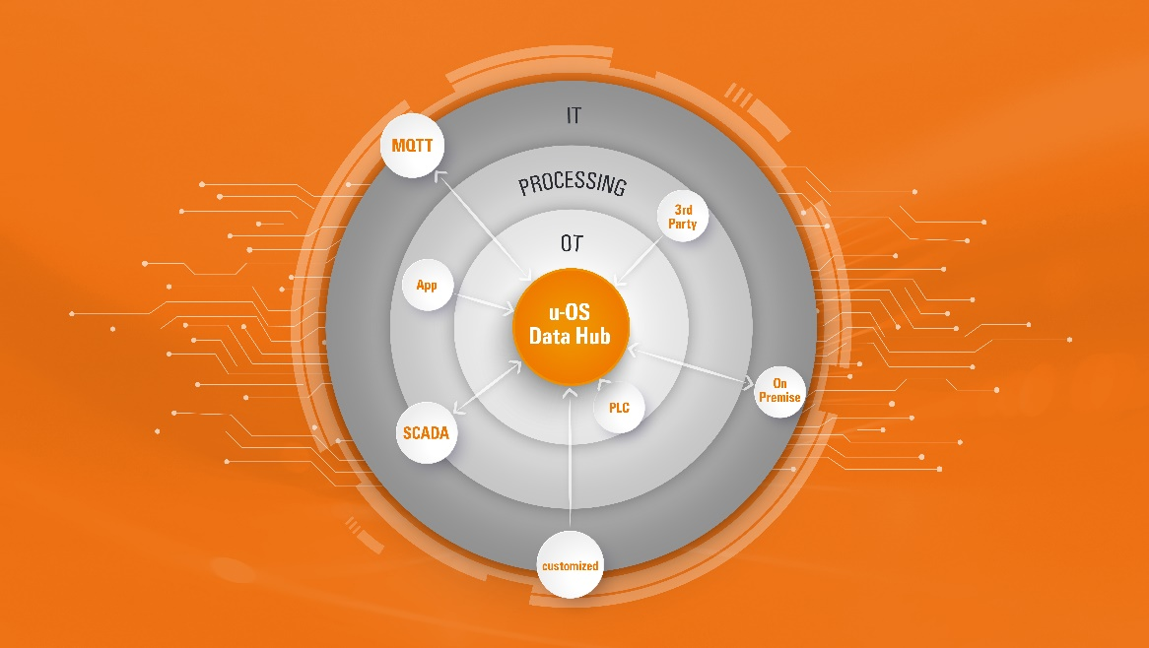
Image caption: The Data Hub networks different applications installed on u-OS with one another.

The Weidmüller Group
Smart Industrial Connectivity: Electrification, automation, digitalisation, electrical connectivity, electromobility and renewable energies – markets in which Weidmüller feels right at home. The family-owned company established in 1850 has production facilities and sales companies in over 80 countries. As a global player in electric connection technology, Weidmüller achieved a turnover of more than one billion euros in the 2023 financial year with around 6,000 employees worldwide - around 2,000 of whom work at the company's headquarters in Detmold, in the heart of East Westphalia-Lippe, Germany. What Weidmüller lives by: Diversity with respect.
Technologies and engagement for a liveable future - Weidmüller demonstrates how it approaches the topic of sustainability in its interactive sustainability brochure.

Your contact person: Weidmüller Corporate Communications
Tel.: +49 5231 14-292322
Email: presse@weidmueller.com

