Networking of technology and expertise for smart cabinet building
Weidmüller, Komax, Zuken and Armbruster Engineering set up the "Smart Cabinet Building" initiative for new solutions in the field of control cabinet building

Detmold, 20. April 2020. Increasing the potential of digitilisation in cabinet building processes with tailored, consistent solutions. To this end, the companies Weidmüller, Komax, Zuken and Armbruster Engineering founded the "Smart Cabinet Building" initiative in April. These companies are technology leaders in various sectors of cabinet building, who are now bundling their competencies and know-how for the very first time. "The aim is to provide integrated solutions for current and future challenges in the area of cabinet building by networking technology and expertise across all process steps", explains Volker Bibelhausen, CTO and Speaker of the Executive Board at Weidmüller.

Holistic approach to the value-added process
Digitalisation offers vast potential to improve manufacturing processes. However, productivity can only be successfully increased by taking a comprehensive view to the individual aspects of the value chain. Huge efficiency increases can be achieved taking advantage of the optimisation potential that exists in the interfaces between the individual process steps. "Cabinet building in particular, with its still high ratio of manual activities, offers very promising approaches here. This ranges from component selection to the pre-assembly of wire harnesses, equipment and housings, right through to assisted final assembly and testing prior to commissioning", explains Matijas Meyer, CEO of the Komax Group.

Perfect complementary expertise
Weidmüller is incorporating its expertise in the automatic assembly and marking of terminal blocks, as well as in manual tasks. Zuken is contributing its competence in digital development data that is provided for automatic processing and used on Komax machines for fully automated wire processing, while Armbruster Engineering complements the initiative with its long-standing expertise in assisted assembly.

Perfect interaction of product, process and production equipment
"Panel building is situated in a pronounced field of conflict: An almost unmanageable number of technical features in the face of fast-changing customer requirements, high cost and price pressure with tight deadlines. This can only succeed if the possibilities opened up by automation and digitalization are adopted to create a perfect interaction between product, process and production equipment. Especially the combination of fully automated solutions and digital assistance systems that guide the employee during manual installation as well as control and monitor the tools being used is a key factor for success factor in practice", explains Henning Vogler, Managing Director at Armbruster Engineering.

The digital twin as the base
The base for networking the process steps is the “digital twin”, a complete digital description of the control panel and its components that can be used to drive the various process steps. Joachim Frank, Managing Director at Zuken E3 GmbH, adds: "Through the cooperation in the 'Smart Cabinet Building' initiative, we want to make our contribution to developing substantial optimization potential in building electrical cabinets including their interconnects based on the digital twin."

3,391 characters including spaces
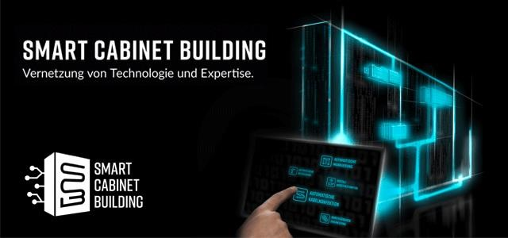
Capture: The aim of SMART CABINET BUILDING is to provide holistic solutions for current and future challenges in switch cabinet construction by networking technology and expertise across all process steps.

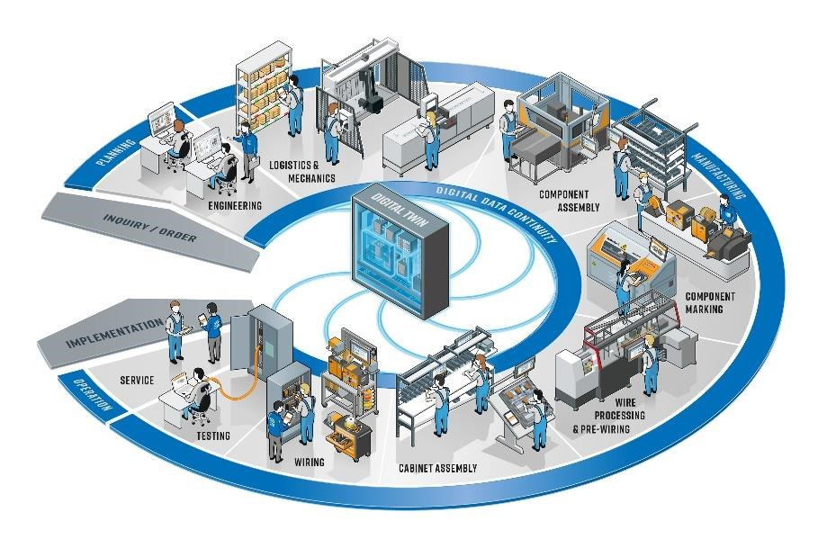
Caption 2: From the selection of components and the prefabrication of cable harnesses, equipment and housings to assisted final assembly and testing prior to commissioning, the partners cover the complete range.

Weidmüller – your partner in industrial connectivity.
As experienced experts we support our customers and partners around the world with products, solutions and services in the industrial environment of power, signal and data. We are at home in their industries and markets and know the technological challenges of tomorrow. We are therefore continuously developing innovative, sustainable and useful solutions for their individual needs.
Together we set standards in Industrial Connectivity.
The Weidmüller Group owns manufacturing plants, sales companies and representatives in more than 80 countries.
In its fiscal year 2019 Weidmüller achieved sales of 830 million Euros with 5,000 employees.

Komax – leading the field now and in the future
As a pioneer and market leader in the field of automated wire processing, Komax provides its customers with innovative and sustainable solutions for any situation that calls for precise contact connections. Komax manufactures series and customer-specific machinery for various industries, catering for every degree of automation and customization. Its range of quality tools, test systems, and intelligent networking solutions complete the portfolio, and ensure safe and efficient production.
The Komax Group employs more than 2200 people worldwide and provides sales and service support via subsidiaries and independent agents in more than 60 countries.

Zuken - Engineering solutions for control cabinet building
With its E3.series suite of E-CAD software applications, Zuken has been a trendsetter for production-related engineering in the fields of electrical engineering, automation and control cabinet engineering. Zuken's software solutions enable a seamless flow of information from circuit and cable diagram to digitally controlled control cabinet manufacturing according to the concept of a digital twin.
The Zuken Group, based in Yokohama, Japan, is a leading global provider of electrical and electronic design automation solutions. Zuken employs more than 1300 people worldwide and maintains research and development centers in Japan, Germany, the United Kingdom and the USA.

Armbruster Engineering – The assistance system for manual productions
Armbruster Engineering is providing innovative solutions for manual productions in various industries and company sizes for more than 20 years. Based on our ELAM system we establish a secure supply of parts and a controlled assembly for our customers.
With its unique range of assistance functions we strengthen the shop floor level with digital worker guidance and process control and connect it perfectly with the company's ERP system. Over 1,200 ELAM systems are currently worldwide in use in the field of logistics, assembly, testing and packaging.

