Monitoring Solutions for Photovoltaic Systems
Increased Efficiency with PV Retrofit Combiner Boxes and PV Weather Stations by Weidmüller

Photovoltaic systems are a key component of the energy transition. To unlock the full potential of these systems, accurate monitoring and a robust data foundation are essential. Retrofit solutions for string monitoring and PV weather stations enable existing ground-mounted PV installations to operate more efficiently, significantly improving their economic viability.

Retrofit Monitoring as the Key to Performance Optimisation
Many older PV systems were installed without string-level monitoring – a decision that today often proves to be a bottleneck for efficiency. The so-called zone monitoring, which observes the system at inverter input level, is insufficient for reliably identifying faults at the module level. As a result, operators risk overlooking yield losses over extended periods.

This is precisely where Weidmüller’s retrofit solutions come in. By upgrading systems with retrofit PV combiner boxes featuring integrated string monitoring, operators gain detailed insights into string-level performance. This allows for targeted fault analysis, reduces downtime, and sustainably increases the system’s Performance Ratio (PR).

Technical Implementation: Flexible, Scalable, and Wireless
Weidmüller offers modular monitoring components with 8 to 12 inputs, expandable to up to 32 strings. Thanks to wireless communication via LoRaWAN®, there is no need for additional data cabling – reducing both installation effort and maintenance costs. The systems are designed for currents up to 50 ADC and can be seamlessly integrated into existing DC combiner boxes.

Alternatively, pre-assembled retrofit boxes are available for quick installation near existing connection points. Various versions with differing numbers of inputs and connection types (PV connectors or cable glands) offer high flexibility for retrofitting applications.

Monitoring Without a SCADA System
Weidmüller’s solutions are compatible with both Modbus/RTU and Modbus/TCP, allowing straightforward integration into existing SCADA systems. Alternatively, a standalone communication module is available that records, stores, and, if required, transfers data to the cloud – independent of SCADA infrastructure. This makes comprehensive monitoring accessible to smaller operators without the need for additional IT infrastructure.

Compliance with the IEC 61724-1-ed2.0 standard for data acquisition and storage ensures standardised and traceable access to data. Integration into cloud services also enables advanced applications such as predictive maintenance and energy yield forecasting.

Added Value Through PV Weather Stations: Context for Data
Beyond current monitoring, the inclusion of weather data provides valuable context for assessing PV system performance. Weidmüller offers weather stations that record all relevant environmental parameters – including solar irradiance (both global horizontal and plane-of-array), module and ambient temperature, wind direction and speed, relative humidity, barometric pressure, and precipitation.

These robust PV weather stations are modular, customisable to individual customer requirements, and compatible with a wide range of industry-standard sensors (e.g. from Hukseflux, Kipp & Zonen, Lufft). Data is transmitted directly to SCADA systems or external platforms via standard protocols such as Modbus.

Sustainable Yield Optimisation Through Targeted Retrofitting
The combination of retrofit combiner boxes with string monitoring and PV weather stations enables in-depth performance analysis. Operators are empowered to identify inefficiencies early, implement targeted maintenance, and maximise energy yields. In light of growing demands for transparency and profitability, this represents a decisive competitive advantage – not only for new but especially for existing PV installations.

3,932 characters including spaces

You are free to use all images. You can download them via the following link: https://www.picdrop.com/weidmueller/trZjewXt5k
We request that you cite the image source Weidmüller.

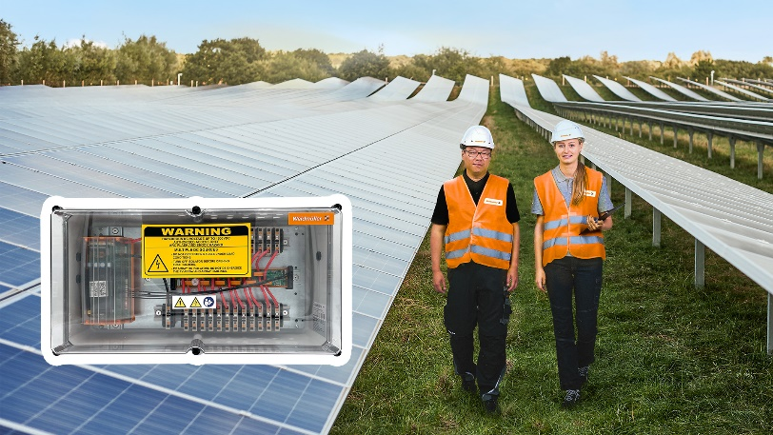
Image caption: Weidmüller’s retrofit PV combiner boxes with string monitoring enhance measurability and improve operational efficiency.

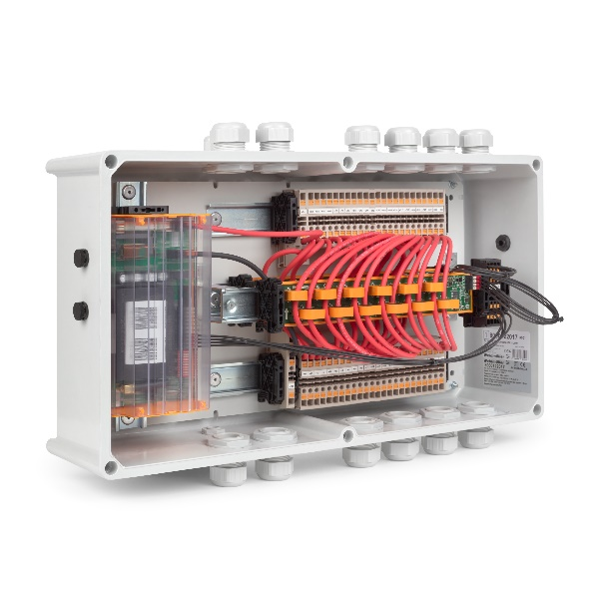
Image caption: String-level monitoring enables detailed fault analysis, minimises downtime, and sustainably increases the system’s Performance Ratio (PR).

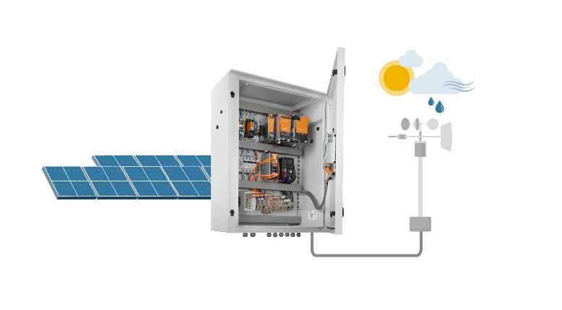
Image caption: Weidmüller’s modular PV weather stations are designed for flexible integration with SCADA systems and various data acquisition platforms via industry-standard communication protocols such as Modbus RTU and TCP.

The Weidmüller Group
Smart Industrial Connectivity: Electrification, automation, digitalisation, electrical connectivity, electromobility and renewable energies – markets in which Weidmüller feels right at home. The family-owned company established in 1850 has production facilities and sales companies in over 80 countries. As a global player in electric connection technology, Weidmüller achieved a turnover of one billion euros in the 2024 financial year with around 5,700 employees worldwide - around 2,000 of whom work at the company's headquarters in Detmold, in the heart of East Westphalia-Lippe, Germany. What Weidmüller lives by: Diversity with respect
Technologies and engagement for a liveable future - Weidmüller demonstrates how it approaches the topic of sustainability in its interactive sustainability brochure.

Your contact:
Weidmüller Corporate Communication
Marc Landermann, Head of Corporate Communication
Tel.: +49 5231 14-292322
Email: presse@weidmueller.com

