Press release 

Weidmüller and IDEC announce strategic partnership
The close cooperation between Japanese and German companies in the field of connection technology focuses on terminal blocks with PUSH IN connection technology

Osaka / Detmold, 19 March 2019. The German electrical engineering company Weidmüller and the Japanese IDEC industrial automation group announced their strategic partnership at IDEC's headquarters in Osaka. The close cooperation, which officially begins in April 2019, is set to focus on the implementation of PUSH IN wire connection technology on the Japanese market, which will be distributed exclusively by IDEC in Japan. "We are delighted to have found in IDEC a powerful partner with a strong distribution network, an excellent name and outstanding service", explains Weidmüller Sales Director José Carlos Álvarez Tobar.
IDEC has a wide-ranging portfolio and know-how in the manufacture and distribution of control devices and systems, as well as components and equipment for factory automation systems, and generates around 46 percent of its sales on the Japanese domestic market. In order to compete in this highly competitive technology market and initiate new innovations through the synergy of specialist knowledge, from now on both companies will pool their expertise in the field of connectivity.
The German family-owned company Weidmüller is known above all for its expertise in connectivity, as well as automation and digitalisation. For Weidmüller, this is an interesting growth area, as the Japanese market is facing major change. "Traditional connection technology is increasingly being replaced by innovative connection technologies, such as the PUSH IN connection system", explains Álvarez Tobar. "With our Klippon Connect modular terminal block portfolio and the A-Series with advanced PUSH IN connection technology, we have one of the most innovative connection systems in panel building and industrial connectivity in the world at our disposal".
1.981 characters including spaces

1

Press release

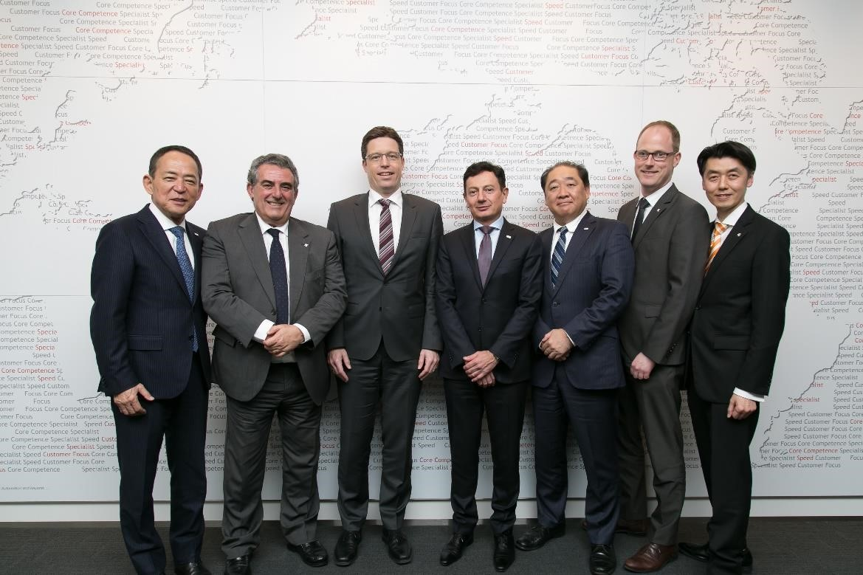
Image caption: The German electrical engineering company Weidmüller and the Japanese IDEC industrial automation group announced their strategic partnership at IDEC's headquarters in Osaka

Weidmüller – your partner in industrial connectivity.
As experienced experts, we support our customers and partners around the world with products, solutions and services in the industrial environment of power, signal and data. We are at home in their industries and markets and are aware of the technological challenges of tomorrow. We are therefore continuously developing innovative, sustainable and useful solutions for their individual needs. Together we set standards in Industrial Connectivity.
The Weidmüller Group owns manufacturing plants, sales companies and representatives in more than 80 countries.
In its fiscal year 2017 Weidmüller achieved sales of 740 million Euros with 4,700 employees.

Contact: Carsten Nagel
Corporate Communication
Tel.: +49 (0)5231 / 14-291010
E-mail: carsten.nagel@weidmueller.com
2

