Single Pair Ethernet – applications in data communication
Single Pair Ethernet is now available in numerous applications, meaning that device manufacturers can already integrate SPE today when developing next-generation devices.

The key technology for the next generation of industrial automation
Increasing industrial automation requires sensor and actuator landscapes of ever greater complexity which must be integrated into efficient and scalable communication networks. Single Pair Ethernet (SPE) plays a key role here, as it enables end-to-end Ethernet communication from the enterprise level to the sensor and actuator level. One decisive advantage of SPE is its ability to bridge large distances of up to 1,000 metres without additional gateways. In addition, the integration of Power over Data Line (PoDL) enables SPE to transmit both data and energy via a single wire pair. These properties make SPE a pioneering technology for the next generation of industrial automation in the context of the Industrial Internet of Things (IIoT).
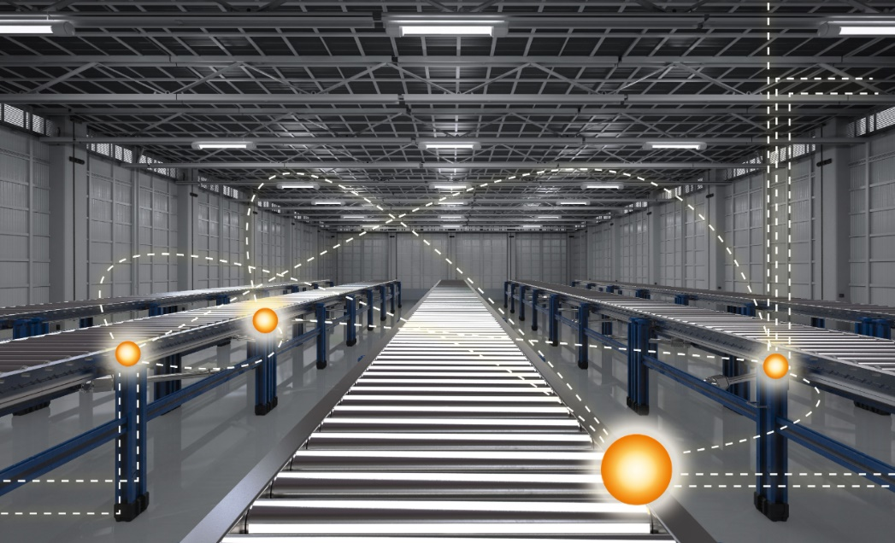
Image caption: Improved data acquisition and process control in industrial automation: High system availability thanks to data

SPE for optimised robotics – increased efficiency and miniaturisation
Single Pair Ethernet enables significant advances in the miniaturisation of communication infrastructures and the development of sophisticated end-of-arm tools for robots. Unlike conventional protocols, SPE offers a large bandwidth, which means that communication between a robot arm and its controller can efficiently process large data frames. The Power over Data Line (PoDL) function simplifies cabling along the robot body by transmitting both data and power through a single cable.
SPE supports high-resolution 2D or 3D robot vision systems by enabling data transmission at speeds of up to 1 Gbit/s over distances of up to 40 metres. Moreover, SPE cables have a small bending radius compared to conventional automation cables, potentially allowing a reduction in the overall dimensions of the robot body and arm. This compact and efficient cabling solution increases the performance and design flexibility of robotic systems.

Process industry with Ethernet-APL
Ethernet-compatible interfaces are increasingly required in the process industry to access data from the field via the IIoT. The challenge here is that information is required from sensors and devices in the field, which means that large distances need to be bridged. In addition, various IIoT devices must be integrated into the network infrastructure. Single Pair Ethernet for the process industry is referred to as “Ethernet-APL” (Advanced Physical Layer), a special definition of 10Base-T1L enriched with functional safety that requires qualified components for reliable data transmission at 10 Mbit/s and a simultaneous power supply via a twisted-pair cable at distances of up to 1,000 metres. Ethernet-APL technology enables direct access down to the field and device level by employing an internationally standardised two-wire solution. This requires powerful IIoT devices with qualified components. The results are increased system availability and more production data: it is easy to collect, use and analyse data from devices in the field, and this helps to ensure and increase system availability and implement new solutions.


Image caption: Ethernet APL plays a particularly important role in the process industry

Building automation
The integration of the Internet of Things (IoT) into building automation has become a crucial factor in the current digital transformation and promises to become even more important in the future. Adopting the IP protocol makes building automation more streamlined and effective, as it allows sensors, controllers and other building technologies to be seamlessly connected to the building system technology, even over long distances. This method replaces conventional proprietary fieldbus systems with standardised Ethernet cabling, eliminating the need for expensive and time-consuming programming and parameterisation. Single Pair Ethernet makes additional gateways unnecessary. In the planning and development of intelligent buildings, there is a clear trend towards minimising the energy consumption of all connected devices. Single Pair Ethernet plays a vital role here. It enables the simultaneous transmission of high-performance data and power via a single wire pair through the use of Power over Data Line (PoDL). In addition, SPE components, including plug-in connectors and cables, are designed to be intelligent, durable and efficient. SPE allows the integration of building systems such as lighting, heating, ventilation, air conditioning and security into a unified network that is easy to install and maintain. Thanks to its ability to support different transmission distances and rates and its high package density, this connection technology is highly adaptable to virtually any system. In addition, SPE is essential for IoT devices, as it enables compact, energy-efficient designs with reliable Ethernet connectivity.
This is crucial for applications such as intelligent power grids, smart cities and home automation.
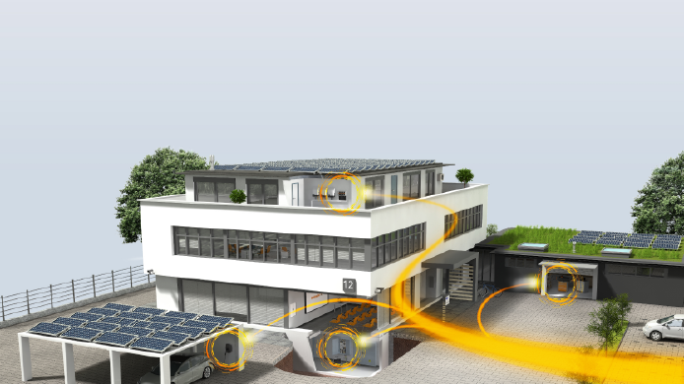

Image caption: Seamless integration of sensors and controllers into building system technology

Benefits for infrastructures
Thanks to its ability to transmit data over greater distances than conventional Ethernet, Single Pair Ethernet can also be beneficial for infrastructure applications. This makes SPE particularly useful for large infrastructure projects that require a long range and high data rates, such as tunnels and railway crossings. It can be used to control and supply power to signals, to connect and supply power to sensors, and to control actuators. SPE simplifies the complex cabling required for extensive installations, such as track-side systems and traffic control networks. Since SPE delivers both power and data over the same pair of wires (PoDL), it is easier to install and maintain devices such as sensors and cameras for traffic control and monitoring systems. The compatibility of SPE with existing Ethernet-based systems ensures seamless integration and enables the efficient use of intelligent infrastructure solutions that require real-time data exchange and monitoring. In addition, the scalability of SPE makes it ideal for expanding existing infrastructure projects: it can easily accommodate increasing data requirements and the addition of new devices without having to make major changes to existing equipment.

SPE in the energy sector
Single Pair Ethernet also offers numerous benefits for the energy sector. Its ability to support high-speed data communication over long distances makes it ideal for monitoring and controlling remote energy facilities, such as wind turbines, solar farms and substations. In conjunction with PoDL, SPE facilitates the use of smart grid devices, sensors and actuators and simplifies the integration of IoT technologies. In addition, real-time data exchange and monitoring with SPE are decisive factors for efficient energy management and predictive maintenance while ensuring the stability and reliability of the power grid.


Image caption: Real-time data exchange and monitoring with SPE
6,862 characters including spaces

You are free to use all images. We request that you cite the image source.

The Weidmüller Group
Smart Industrial Connectivity: Electrification, automation, digitalisation, electrical connectivity, electromobility and renewable energies – these are markets in which Weidmüller feels right at home. The family-owned company established in 1850 has production facilities and distributors in over 80 countries. As a global player in electrical connectivity, in 2023 Weidmüller reported revenue in excess of one billion euros with around 6,000 employees worldwide – approx. 2,000 of whom are located at the headquarters in Detmold in the heart of Ostwestfalen-Lippe, Germany. Values Weidmüller lives by: Diversity with respect.

Technologies and engagement for a liveable future – Weidmüller demonstrates how it approaches the topic of sustainability in its interactive sustainability brochure.

Contact:
Weidmüller Corporate Communications
Company Spokesperson, Sybille Hilker
Tel.: +49 (0)5231 / 14-292322
Email: presse@weidmueller.com

