Klippon® RailSnapper: Just click fully equipped DIN rails directly on the mounting plate
For production to run smoothly, efficient space utilisation and effortless installation are essential. To ensure the proper fastening of the rail to the mounting plate, efficient space must be provided for fixing the DIN-rail with screws or rivets between the terminal blocks. Failure to do this results in a less-than-optimal utilisation of the available space. At present, the fastening points of the DIN-rail must be taken into account during assembly, or the DIN-rail must be fixed to the mounting plate before components are fitted. In the worst case, components must even be removed first and then refitted after fastening.
The future of terminal rail mounting is now
The Klippon® RailSnapper allows the full utilisation of the entire rail length. The entire length of the rail can be fitted with components and then pressed directly onto the mounting plate and installed in the assembly hall. For this purpose, the fastening screws are screwed onto the mounting plate prior to installation. The Klippon® RailSnappers are positioned in such a way that they can be subsequently guided through the slotted holes in the rail during installation. During the later installation of the fully fitted rail, the spring-loaded screws snap into place over or behind the detached mounting rail. The snap-in action of these spring-loaded elements holds the rail in place and presses it against the mounting plate. If the mounting rail lies flat on the mounting plate, the PE short-circuit current can be discharged in accordance with IEC 60947-7-2 up to a wire crosssection of 16mm². There is no need for an additional PE conductor with a connection on a PE terminal block.
Better standards and processes in the electrical industry
Process steps such as fitting the terminal block and installation can be separated from each other. This means that process steps can be split up – a major plus in times of a shortage of skilled labour. This leads to greater efficiency in the entire switch cabinet construction process. The rail can be assembled by unskilled labour, external partners or even in automated process steps. Skilled labour can concentrate on technical wiring or other complex tasks. This optimises the use of resources and increases efficiency. The Klippon® RailSnapper can be pre-installed using an integrated screw or, for larger quantities, using a rivet and a suitable riveting tool.
2,484 characters including spaces

Image caption: The Klippon® RailSnapper allows the full utilisation of the entire rail length

Image caption: Installation is possible using an integrated screw or, for larger quantities, using a rivet and a suitable riveting tool.

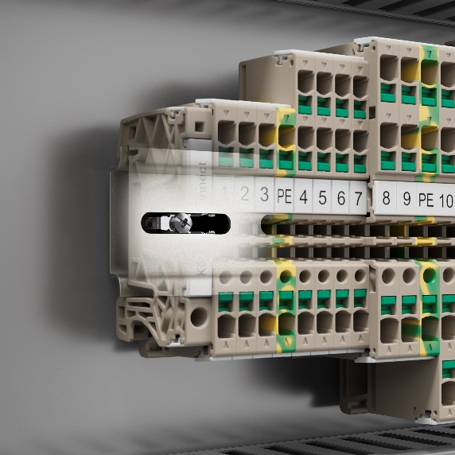
Image caption: Klippon® RailSnappers are positioned in such a way that they can be subsequently guided through the slotted holes in the rail during installation

You are free to use all images. We request that you cite the image source.

The Weidmüller Group

Smart Industrial Connectivity: Electrification, automation, digitalisation, electrical connectivity, electromobility and renewable energies – markets in which Weidmüller feels right at home. The family-owned company established in 1850 has production facilities and distributors in over 80 countries. As a global player in electrical connectivity, in 2022 Weidmüller reported revenue in excess of one billion euros with around 6,000 employees worldwide – approx. 2,000 of whom are located at the headquarters in Detmold in the heart of Ostwestfalen-Lippe, Germany.
Responsible for content:
Weidmüller Corporate Communications
Company Spokesperson, Sybille Hilker

Contact for this press release:
Weidmüller Corporate Communications
Tel.: +49 (0)5231 / 14-292322
Email: presse@weidmueller.com

