Learning while welding

Weidmüller is developing an industrial analytics tool to monitor the friction stir welding processes of the Grenzebach Group

The internationally operating Grenzebach Group and the electrical engineering and automation company Weidmüller are working together in the fields of data analysis and predictive maintenance. Their research focuses on condition and quality monitoring for friction stir welding technology. Customised analysis software from Weidmüller is used to monitor the welding process. In the future, it will be able to automatically detect and record anomalies in the welding process.

Innovative technology
Friction stir welding is a form of pressure welding. The joint is not melted; instead, enormous pressure and a rotating tool heat the material during the welding process, making it plastically deformable. At the same time, the tool pin rotates, stirring the components to be joined. The process can be used to join light metals like aluminium, ensuring secure, heat-resistant, long-lasting bonds.
The welding joints created are among the most stable of any welding method. Friction stir welding is therefore mostly used for electromobility components and in critical sectors, such as aerospace. The process creates joints that would otherwise be impossible with the use of other welding technologies. Another advantage of the technology is that it does not generate smoke, sparks or toxic gases.

Dual monitoring for greater quality
The Grenzebach Group supplies systems for this welding process. In order to support its customers’ quality control processes, the company is expanding the technology to include “AutoML”, Weidmüller’s industrial analytics tool. This adds a data-driven approach to complement conventional inspections of welded parts, thereby increasing the weld quality. “We want our customers to manufacture products with the best possible quality and keep abreast of any deviations early on”, explains Christian Herfert, Senior Vice President Special Technologies at Grenzebach.
Industrial AutoML records and analyses sensor data during the welding process. This includes, for example, the mechanical forces applied to the tool. The analytics tool combines the data and processes it further. After teaching the tool through hundreds of standard welds, the system creates models that are capable of detecting welding deviations automatically. “Our software compares the measured values with the trained welds. If the software detects a deviation from the defined parameters, the operator knows that something is wrong”, explains Dr Daniel Kress, Data Scientist at Weidmüller.
Grenzebach uses numerical labelling to assign a brand to each dataset. This data is forwarded to Industrial AutoML so that customers can view and track the quality of each workpiece individually. The reliable documentation of deviations increases transparency for customers.

The number of specialists in this new technology is still limited. Grenzebach employees working in this field can now expect to receive comprehensive support. Defects that cannot be discerned with the naked eye are detected by the software. These can be specifically taken into account in the workpiece control process, which increases product quality. And the additional documentation provided by Industrial AutoML doubles the level of security for Grenzebach customers.

A partnership for more customer benefits
The Grenzebach Group and Weidmüller are working together to give customers of the welding machine manufacturer all the benefits of simplified processes. In addition to the improved documentation of welding processes, Industrial AutoML also enables reliable predictive maintenance. The generated data can then be used to create machine learning paradigms that detect critical measurements and energy-intensive processes completely automatically. In a downstream operation, these can be further developed to aid sustainable production based on the user’s requirements or used as an ML solution to support quality specialists. Grenzebach is thus optimising its machines and upgrading them in line with the increased demands placed on modern systems. In this way, the company can not only ensure high manufacturing quality, but also simplify interactions between the system operator and the system. Customers now stand to gain added value from their production data, even without a data scientist.
Weidmüller offers a wealth of products and solutions for industrial IoT and automation. “As an ‘enabler from data to value’, it is important to us to help our customers get added value from their data for themselves and their company”, explains Dr Thomas Bürger, Head of the Automation Products and Solutions Division at Weidmüller. Weidmüller provides its customers with innovative concepts for data collection, pre-processing, analysis and visualisation.

Characters including spaces – 4998

You are free to use all images. We request that you cite the image source (image rights: Grenzebach).
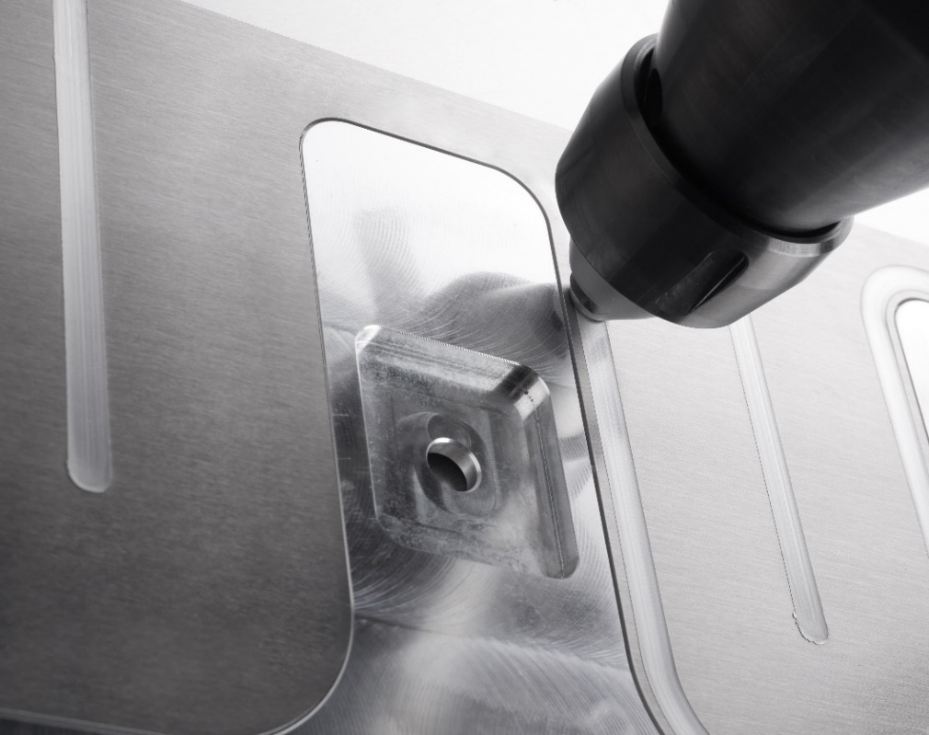
Image caption: The welding pen stirs the two workpieces together

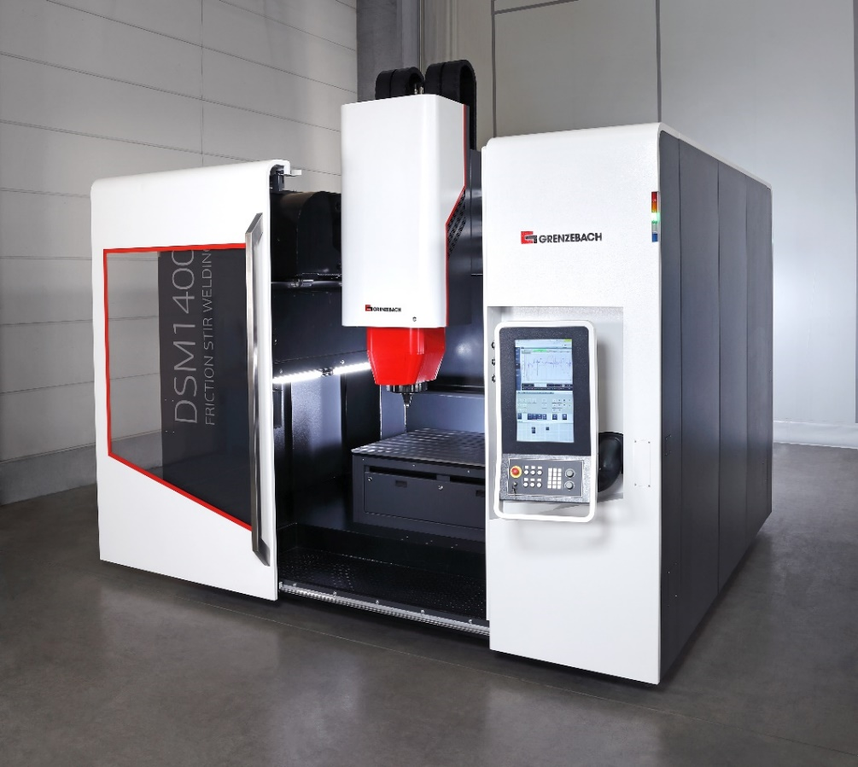
Image caption: The weld measurements can be viewed and analysed on the systems

About Grenzebach
Grenzebach provides customised automation solutions for the global glass, building materials and intralogistics markets. In addition, the company is constantly tapping into new applications, including various recycling processes, friction stir welding, automation for additive manufacturing, digital networking and solutions for sustainable energy generation, such as solar-active façades. Grenzebach is a global technology leader in its markets. Production sites in Germany, Romania, the USA, India and China as well as agencies worldwide provide local customer service. With more than 3,000 installed systems in 55 countries, Grenzebach stands for quality and reliability – and has done so for over 60 years. Since its foundation, the medium-sized group of companies has been owned by its founding family and, with an export rate of over 90 per cent, is firmly established as a global player.

The Weidmüller Group

Smart Industrial Connectivity: Electrification, automation, digitalisation, electrical connectivity and renewable energies – markets in which Weidmüller feels right at home. The family-owned company established in 1850 has production facilities and sales companies in over 80 countries. As a global player in electric connection technology, Weidmüller achieved a turnover of almost one billion euros in the 2024 financial year with around 5,700 employees worldwide - around 2,000 of whom work at the company's headquarters in Detmold, in the heart of East Westphalia-Lippe, Germany. What Weidmüller lives by: Diversity with respect.
Technologies and engagement for a liveable future - Weidmüller demonstrates how it approaches the topic of sustainability in its interactive sustainability brochure.

Your contact person: Weidmüller Corporate Communications
Marc Ladermann, Head of Corporate Communication
Tel.: +49 5231 14-292322
Email: presse@weidmueller.com

