Weidmüller takes part on international lightning protection conference
For the 37th time, the VDE (Verband der Elektrotechnik Elektronik Informationstechnik e.V.) is inviting lightning protection experts from research and industry to come together and exchange ideas. This year, the exhibition will be held in the Bilderberg Hotel Dresden, Germany.

This year's ICLP (International Conference on Lightning Protection) will begin on 01 September 2024 in Dresden. Experts in lightning and surge protection from Weidmüller will be on site from 01 to 07 September 2024. They are looking forward to expert discussions and intensive conversations about the latest technological developments and advancements in this field. The ICLP brings together technical experts, researchers, and companies to discuss the latest advancements and innovations in lightning protection technology. This year, the programme will focus on topics such as lightning protection for power grids, electric vehicles and their charging infrastructures, and on the protection of renewable energy systems. Weidmüller has offered standard-compliant lightning and surge protection products for many years and recently adding products for power and photovoltaics systems to the VARITECTOR portfolio. Attendees at the ICLP can look forward to technical discussions and innovative products for power and PV systems at Weidmüller's exhibition stand.

More information about the ICLP 2024 is available here: ICLP 2024 - Homepage - VDE
1,490 characters including spaces

You are free to use all images. We request that you cite the image source.

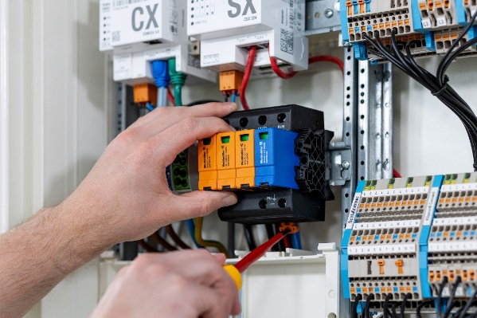
Image caption: The standard-compliant lightning and surge protection products of the VARITECTOR portfolio were recently expanded to include additional products for energy and photovoltaic systems

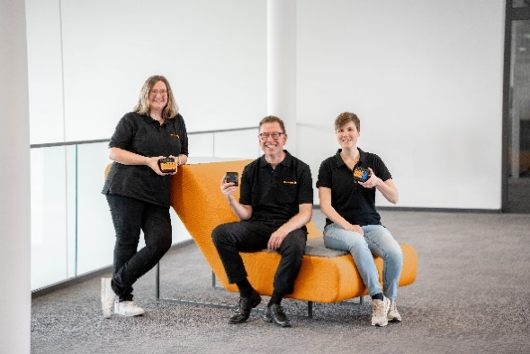

Image caption: Experts in lightning and surge protection from Weidmüller will be on site from 01 to 07 September 2024 at the ICLP in Dresden

The Weidmüller Group
Smart Industrial Connectivity: Electrification, automation, digitalisation, electrical connectivity, electromobility and renewable energies – these are markets in which Weidmüller feels right at home. The family-owned company established in 1850 has production facilities and distributors in over 80 countries. As a global player in electrical connectivity, in 2023 Weidmüller reported revenue in excess of one billion euros with around 6,000 employees worldwide – approx. 2,000 of whom are located at the headquarters in Detmold in the heart of Ostwestfalen-Lippe, Germany. Values Weidmüller lives by: Diversity with respect.

Technologies and engagement for a liveable future – Weidmüller demonstrates how it approaches the topic of sustainability in its interactive sustainability brochure.

Contact:
Weidmüller Corporate Communications
Company Spokesperson, Sybille Hilker
Phone: +49 (0)5231 / 14-292322
Email: presse@weidmueller.com

