Native integration of CODESYS Control SL in u-OS

u-OS enables the flexible combination of CODESYS and other automation applications

At SPS 2025, Weidmüller will be demonstrating how powerful control technology and modern software architectures work together perfectly at the CODESYS joint stand: The native integration of CODESYS Control SL into the open operating system u-OS creates a future-proof platform for industrial automation and Industrial IoT.

With the availability of CODESYS Control SL as an app on u-OS, Weidmüller is expanding the possible applications of its open operating system for Industrial IoT and industrial automation. u-OS is an open platform that has been specially developed for flexible software architectures in automation applications. Users get the full functionality of the proven CODESYS system directly on u-OS and can easily install and integrate it into their applications as needed.
Thanks to its open architecture, u-OS allows easy integration of Weidmüller apps, third-party apps and proprietary software modules. Users benefit from a scalable solution that can be individually adapted to project-specific requirements and supports existing engineering workflows.
Whether data acquisition, analysis or communication – u-OS enables the easy integration of additional functions and supports modern machine concepts with high connectivity and ease of maintenance.
With the native CODESYS Control SL app on u-OS, Weidmüller is sending a clear signal for openness, flexibility and practicality in automation. The platform intelligently combines control and expandability – for greater efficiency, scalability and innovation in your projects.
1674 characters including spaces
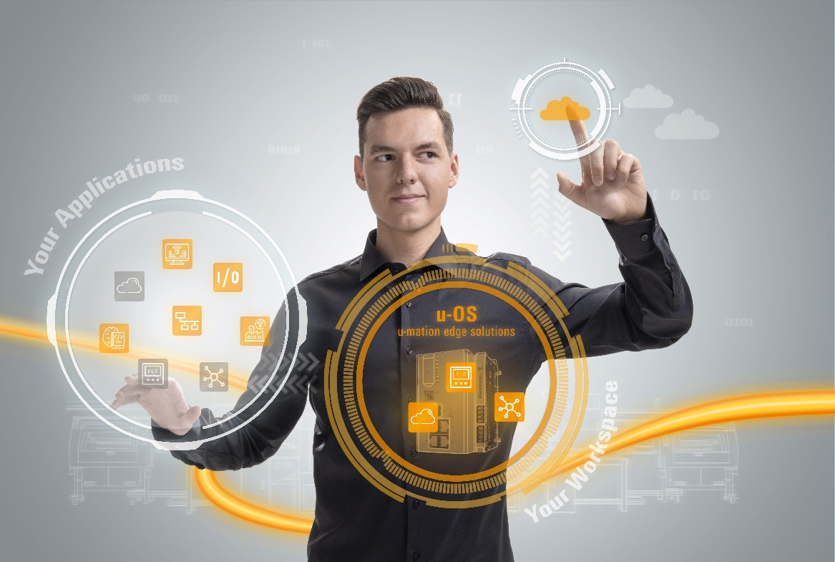
Image caption: u-OS allows easy integration of Weidmüller apps, third-party apps and proprietary software modules.

The Weidmüller Group
Smart Industrial Connectivity: Electrification, automation, digitalisation, electrical connectivity and renewable energies – markets in which Weidmüller feels right at home. The family-owned company established in 1850 has production facilities and sales companies in over 80 countries. As a global player in electric connection technology, Weidmüller achieved a turnover of almost one billion euros in the 2024 financial year with around 5,700 employees worldwide - around 2,000 of whom work at the company's headquarters in Detmold, in the heart of East Westphalia-Lippe, Germany. What Weidmüller lives by: Diversity with respect.
Technologies and engagement for a liveable future - Weidmüller demonstrates how it approaches the topic of sustainability in its interactive sustainability brochure.

Your contact person: Weidmüller Corporate Communications
Marc Ladermann, Head of Corporate Communication
Tel.: +49 5231 14-292322
Email: presse@weidmueller.com

