Optimal separation instead of repairs: GEA is taking the next step in data utilisation with Industrial Analytics from Weidmüller
The option to use data collection and analysis to increase your company's efficiency and productivity and to develop new business models is something that captures the imagination of mechanical and plant engineers looking for new growth and revenue possibilities. GEA has also been involved with condition monitoring for a long time. With the new Automated Machine Learning software from Weidmüller, the company is hoping to expand and develop the services it offers in terms of facilities. A corresponding "pilot" project has been initiated at the GEA site in Oelde, Germany.

Industry 4.0 as a challenge and a major opportunity
Digital technologies and Industry 4.0 pose major challenges for companies in the machinery and plant engineering sector, but they also open up completely new opportunities: it needs to be possible to adapt production facilities in line with individual products and customer requirements. The service business is coming increasingly under the spotlight. "We have been working on condition monitoring and the status monitoring of machines for a long time now, and have also set up threshold analyses. But we also knew that there was a lot more potential in this area", explains Kerstin Altenseuer, Senior Vice President Service Product Management at GEA. "We wanted to map processes and be able to optimise applications together with our customers. And of course, we also wanted to establish new business models and areas of application such as leasing or subscription models for our machines".

Making expertise available in an algorithm
With its 125 years of competence in the manufacturing of separators and decanters for separating liquids, GEA benefits enormously from this experience. These systems are used in various sectors such as the food industry, the chemicals industry and the pharmaceutical industry, as well as in biotechnology, the energy industry, the shipping industry and the environmental technology industry. The company is hoping that the creation of new business models or applications will allow it to tap into new revenue streams. "We also noticed relatively quickly that we need the expertise and assistance of data experts in these projects. The problem with this is that there are not enough data scientists. Identifying the right experts and bringing them on board isn't easy, even when a company seems in principle to have a good hand, as is the case with GEA. But we needed multiple experts, which didn't exactly make things easier", says Kerstin Altenseuer.

Together instead of alone
How can expertise be established with the right experts? It was during its search for a solution to this problem when GEA became aware of Weidmüller and the company's expertise in the field of Industrial Analytics via the "It's OWL" Leading-Edge Cluster. GEA was looking to rethink the services it offers to its customers and to establish a range of smart services. It was also hoping to improve the quality and performance of its machines, and to create a foundation for tapping into new business models in order to position GEA competitively within the market.

Transferring the knowledge of process engineers to an algorithm
GEA and Weidmüller initially started exploring how the project could be set up and which central objective was to be followed. "It soon became clear that we firstly needed to verify the feasibility of the project by means of a Proof of Concept, before enabling GEA to independently develop and operate ML models", explains Tobias Gaukstern, Business Unit Manager Industrial Analytics at Weidmüller. The aim was that by using the Automated Machine Learning software services, the experts at GEA would be able to independently train-in Machine Learning algorithms or statistical models. "The AutoML tool makes it quicker and easier for application experts to use ML, without needing any expert knowledge in the field of ML", explains Tobias Gaukstern. Mechanical engineering companies are often faced with the problem that their design, automation and process experts cannot easily transfer their knowledge to solutions in the field of machine learning. How can this application expertise be pooled together into a piece or software, let alone an algorithm? "We were fascinated by the solution, as we have a lot of process engineers who are very familiar with the machines and who are, to a certain extent, able to interpret the data. With Weidmüller's help, we can now transfer this knowledge to an algorithm", explains Matthias Heinrich, Manager Digital Solutions at GEA. In order to check how the theoretical observations could be applied on site in a production environment at GEA, a Proof of Concept (PoC) was carried out in Oelde using historical data. The objective was to achieve the automatic detection of anomalies in the behaviour of separators in the dairy industry.

The advantage of regional proximity and close collaboration between the partners
The fact that the project was such a success was also down to the good close collaboration within the team. On the one hand, the regional proximity was a big advantage as the project team could easily meet at short notice to discuss individual issues. "Weidmüller has a very wide-reaching knowledge from a data scientist perspective, yet at the same time, you also feel very well understood as a mechanical engineering company, because you're not just meeting with IT specialists but also with engineers who really know the machines", Kerstin Altenseuer explains. As part of this project, GEA managed the input and the requirements, while the "Proof of Concept" was performed at Weidmüller. "This division of the work proved very successful. We had regular and positive coordination and very good results, which have created the foundation for the pilot application and finally for the transfer to series production", explains Tobias Gaukstern.

Additional roll-out planned for 2020
The applications have been implemented in combination with an existing IoT scenario for condition monitoring at GEA. "Everyone's talking about digitalisation, but we want to use it to provide added value even at the end of the line". We want the solution developed by Weidmüller to help us take the next step", says Kerstin Altenseuer. Until then, there are still a few things we need to do before really getting started with 2020, such as improving the data connection and the data quality. "We have so far connected 500 machines to the existing portal, and we are aiming to transfer Weidmüller's solution to these machines as quickly as possible", Kerstin Altenseuer explains. Altenseuer is looking to the future: "I also see a lot of potential for transferring the new technology to other areas at GEA".

6.833 characters including spaces
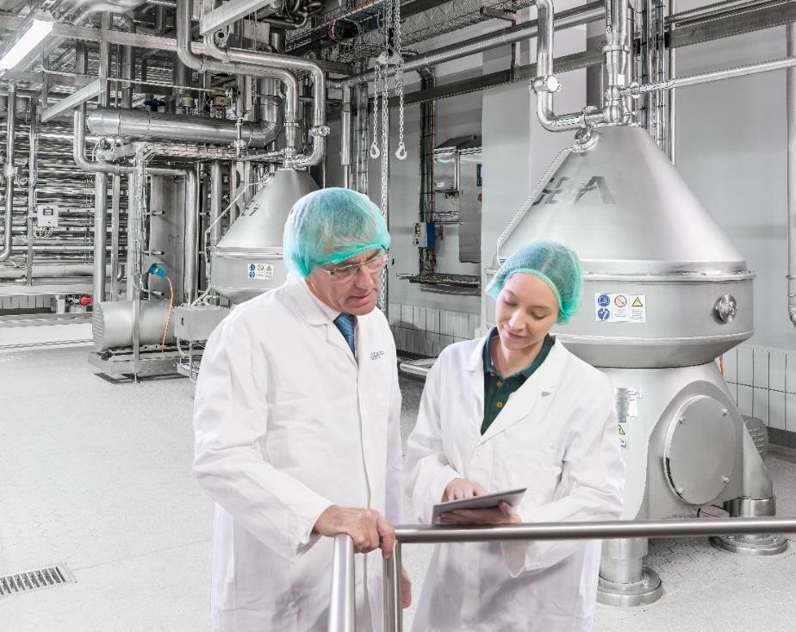
Caption 1: GEA takes the next step in data usage with Weidmüller's Industrial Analytics. (Photo: GEA)

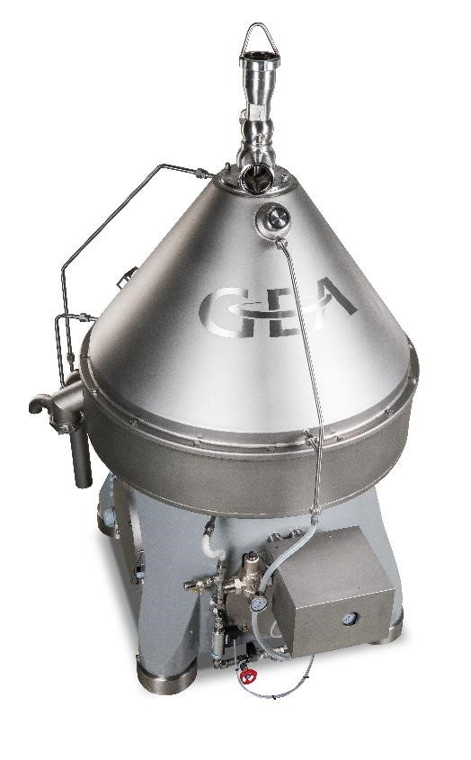
Caption 2: At home in over 3,500 applications: GEA separators in dairies, chemical, pharmaceutical, beverage and many more.

Weidmüller – your partner in industrial connectivity.
As experienced experts we support our customers and partners around the world with products, solutions and services in the industrial environment of power, signal and data. We are at home in their industries and markets and know the technological challenges of tomorrow. We are therefore continuously developing innovative, sustainable and useful solutions for their individual needs. Together we set standards in Industrial Connectivity.
The Weidmüller Group owns manufacturing plants, sales companies and representatives in more than 80 countries. In its fiscal year 2018 Weidmüller achieved sales of EUR 823 million with around 4,900 employees.

Contact: Weidmüller Corporate Communication
Tel.: +49 (0)5231 / 14-292322
E-Mail: presse@weidmueller.com

