Weidmüller awarded German Excellence Prize 2020
Detmold-based electrical engineering company receives the audience prize in the “Digitalisation & Technology” category for its Automated Machine Learning
Tool

Detmold / Berlin, 24 January 2020. On 23 January 2020, electrical engineering firm Weidmüller was presented with the audience prize in the
“Digitalisation & Technology” category of the German Excellence Prize (Deutscher Exzellenz-Preis). The Detmold company's award was for its Automated Machine Learning Tool – software that enables users to create and use machine learning models independently, without any specific knowledge of machine learning. Weidmüller has enjoyed a string of successes, since this innovative software also received the Industry 4.0 Innovation Award in
November 2019. “We are very proud of this latest award, which is both an honour and motivation for us to continue working in the same direction and consistently pursue the path that we have chosen,” explains Tobias Gaukstern,
Head Business Unit Industrial Analytics at Weidmüller, at the award ceremony.
“We are delighted that our software solution won over the community and the jury.”

The digitalisation of industrial production facilities is the main challenge facing machinery and plant operators today. Companies need to utilise data to harness untapped potential, further increase efficiency and productivity and create new business models. Weidmüller software plays a huge part in this. With the Automated Machine Learning Tool, domain experts are able to independently generate an initial ML model for their use case in less than an hour, something which a data scientist would previously have needed several weeks or months to do as part of a project. "With the Automated Machine Learning Tool, we are simplifying the use of machine learning and accelerating the penetration of industrial applications with data-based services, which is key for the future competitiveness of European machine builders and operators,” explains Gaukstern.

The German Excellence Prize 2020 is awarded by the German Institute for Service Quality, DUB UNTERNEHMER magazine and TV broadcaster n-tv. The top-ranking companies in the respective categories attended an award ceremony in Berlin in January 2020.

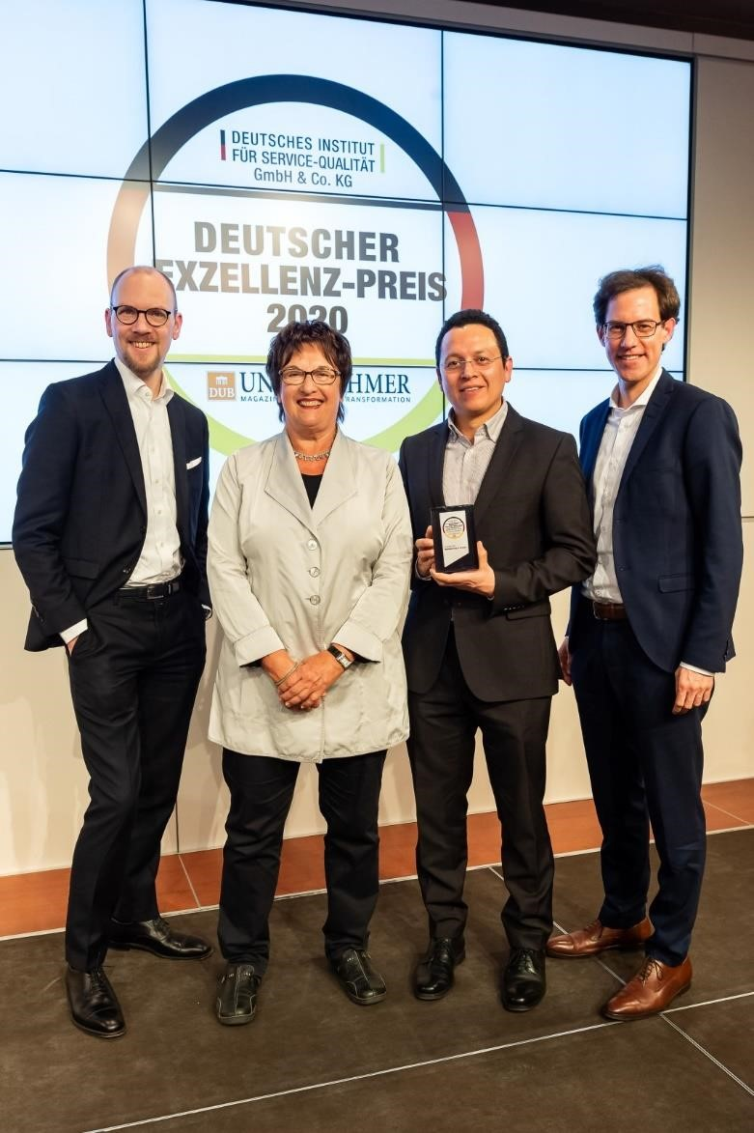
Caption: Dr. Markus Köster (left), Dr. Carlos Paiz Gatica (2nd from right) and Tobias Gaukstern (right) were delighted about the award and received it with thanks from Brigitte Zypries, patron of the award and former Federal Minister (2nd from left). (Copyright: Thomas Ecke / DISQ / n-tv / DUB)

Weidmüller – your partner in industrial connectivity.
As experienced experts we support our customers and partners around the world with products, solutions and services in the industrial environment of power, signal and data. We are at home in their industries and markets and know the technological challenges of tomorrow. We are therefore continuously developing innovative, sustainable and useful solutions for their individual needs.
Together we set standards in Industrial Connectivity.
The Weidmüller Group owns manufacturing plants, sales companies and representatives in more than 80 countries.
In the 2018 financial year, Weidmüller achieved sales of EUR 823 million with around 4,900 employees.

Contact: Carsten Nagel
Corporate Communications Tel.: +49 (0)5231 14-291010 email: carsten.nagel@weidmueller.com

