I/O system adapts to the conditions of smart systems
The u-remote I/O system is now even more powerful thanks to a system update

Weidmüller is equipping the u-remote remote I/O system with new technology for internal backpanel bus communication.

Comprehensive system update for the anniversary

Today, machines and systems produce many different kinds of data, going beyond simple status reports to process controlling. A decentrally installed I/O system must be able to detect incoming signals quickly and precisely, and make them available in the network in use. This is the only way to ensure efficient transmission to the devices that process the data, such as controllers, IPCs or cloud systems. In light of these developments, Weidmüller is elevating its I/O system to an entirely new level. Just in time for the tenth birthday of u-remote, Weidmüller is equipping the I/O system with a comprehensive upgrade to improve the performance of the modules.
In industrial automation, smart sensors are delivering much more complex information. In addition to the actual digital or analogue values measured by the sensor, other information is being transmitted more and more frequently – such as the unit of the measured variable, a time stamp or status information from the sensor. This provides more transparency on the status of a system or its efficiency. This change also has wide-ranging consequences – for data quantity and prioritisation, as well as for data acquisition and processing that ensure the process capabilities of the machine. Now, u-remote is meeting these challenges with a new, even more performant backpanel bus. Thanks to a sevenfold increase in performance capacity, the quantity of data that can be recorded per backpanel bus cycle is significantly higher, greatly improving processing and output of responses. This also makes it possible to record incidents even more precisely. Higher resolution allows control processes to be synchronised in order to further improve the efficiency and effectiveness of the overall system. The entire u-remote I/O product family will successively be equipped with this new chip over time. It is compatible with the previous system.

Successful today and tomorrow

In 2013, electronics company Weidmüller increased its focus on the automation sector. The u-remote remote I/O system continues to impress users today, just as it did ten years ago, through intuitive handling on the software and hardware side. The module’s mechanical advantages, in particular, are a key part of its success. The housing’s narrow width of just 11.5 mm sets it apart from other solutions.
The design of the I/O modules also makes exchanging electronics simple when they are serviced. The three-part basic structure, consisting of terminal strip, electronics and base module, simplifies handling. The swivelling terminal strip makes it possible to exchange the electronics with the existing wiring. This can be removed from the base module and replaced easily and tool-free with the integrated removal lever. Since the supply and communication contacts are completely integrated into the base module, the system is hot-swap capable; the station does not even need to be disconnected from the power supply in order to exchange the electronics. This minimises downtimes and the potential for errors.
At the same time, simple configuration of the installed I/O station ensures solutions are flexible for the user. Each module and the fieldbus coupler can be configured and parameters can be set to meet individual needs. For instance, the measurement ranges for each channel of an analogue input module on a web-capable device can be selected and set individually. This is ensured by the web server integrated into the fieldbus coupler. It can also be used to access all status information, diagnoses and process data on the station. Users also have the option of testing, changing and saving settings directly. These can then be copied to other stations. This allows Weidmüller to ensure simplified series installation of machines and systems. No additional software is needed to do so. The user accesses the web server via one of the USB or Ethernet interfaces integrated on the fieldbus coupler. Data can be accessed via a standard web browser.

Modules for every application

Over ten years, the initial base portfolio of standard I/O modules has developed into a wide selection of over one hundred modules for almost any application. Applications extend far beyond the range of classic mechanical engineering. From shipping to energy technology or the process industry: Weidmüller is constantly advancing u-remote so that it can continue to support users in handling their individual challenges into the future. With eleven communication protocols today, the remote-I/O system can be integrated into almost any automation architecture. This development is made possible by the close collaboration between Weidmüller and its customers. New suggestions are exchanged through communication between partners, to continuously improve the u-remote and adapt it to a wide range of applications.
u-remote is part of the u-mation automation portfolio from Weidmüller. As a partner, Weidmüller offers flexible solutions to meet the requirements of customers in its industry. The comprehensive u-mation portfolio includes products for data collection, pre-processing, communication and visualisation. These include smart u-sense sensors, u-control series controllers, industrial Ethernet switches and the u-OS operating system. Data collection via u-remote is the foundation for the path to industrial IoT.
5636 characters including spaces

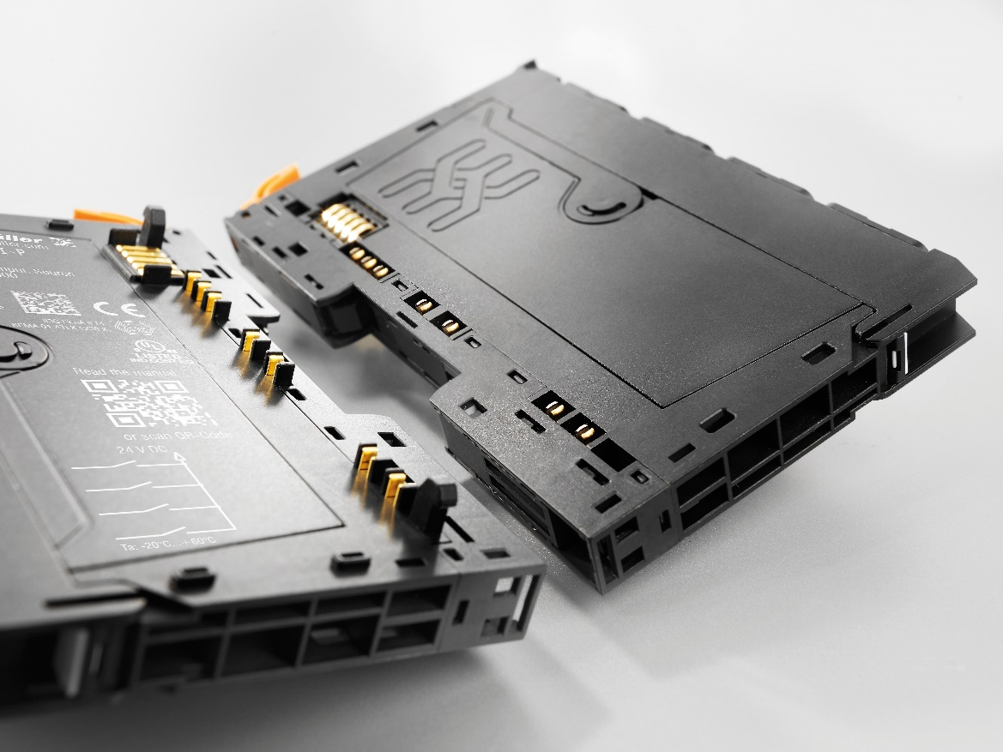
Image caption: The new backpanel bus significantly increases the quantity of data per backpanel bus cycle.
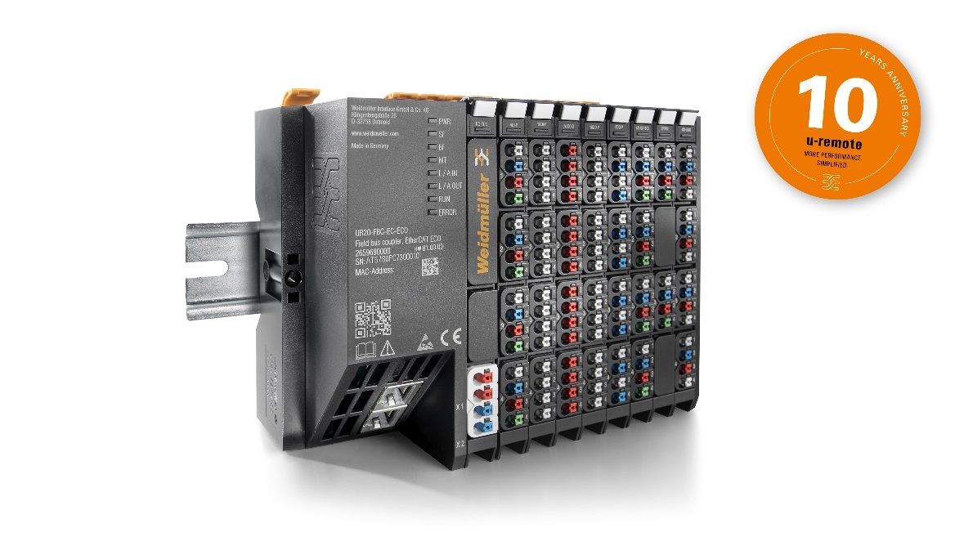
Image caption: Module parameters can be set manually and configured as needed.

Your contact person: Weidmüller Corporate Communications
Tel.: +49 5231 14-292322
Email: presse@weidmueller.com

Weidmüller - Your Partner in Smart Industrial Connectivity
The Weidmüller Group has production facilities, marketing companies and representative offices in over 80 countries. Alongside its customers, the family-owned company from Detmold is shaping the digital transformation – with products, solutions and services for Smart Industrial Connectivity and the Industrial Internet of Things. In the 2022 financial year, Weidmüller generated sales of more than a billion euros with around 6,000 employees.

Responsible for the content: Weidmüller Corporate Communications
Corporate Spokesperson, Sybille Hilker

Calculated based on the maximum possible process data width of an I/O module. This was previously 16 Byte/ms, now up to 128 Byte/ms is supported.

