Technical change to: Current clamp meter 2606

Dear Madam or Sir,

the below listed articles will be supplied in a modified revision. Please pass this product information on to your employees and, if needed, to your customers. All modifications are performed for reasons of product improvements.

- Initial situation

The supplier will no longer manufacture the current clamp meter.

- Technical change

Alternating current increased from 1.000A AC/DC to 1.500A AC / 2.000A DC.
Resistance measurement increased from 40MOhm to 66MOhm.
Frequency measurement increased from 400kHz to 1MHz.
New display instead of 4000 count with 6600 count
New with backlight for digital display

Old version | New version
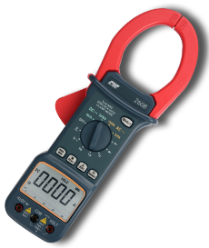 | 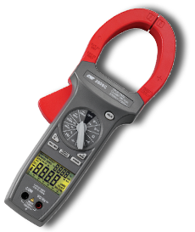

- Reason for change

The supplier will no longer manufacture the current clamp meter. There is therefore an improved new version.

- Availability

The new C 2606 clamp meter is available from stock.

- Affected parts

9427370000 – Multimeter C 2606

- Data

- PCN-PW643010-20200312-00-A
- 12.03.2020

We are very sorry for all the inconveniences caused and doing everything to adjust this product change as smooth as possible without big influence on delivery times and general functions.

For further questions please contact your sales office directly. All contacts for sales representatives are available here: www.weidmueller.com/contact

Best regards

Product Management

Weidmüller Interface GmbH & Co. KG
Klingenbergstraße 16, 32758 Detmold, Germany

Weidmüller – Your partner in Industrial Connectivity
We look forward to sharing ideas with you – Let’s connect.

