Weidmüller Generates Sales of €792 Million in 2020 in Particularly Challenging Market Environment
- Long-term investments in all areas (production, logistics, research & development and sales) secure the future
- Tapping into important future markets such as green hydrogen and DC INDUSTRY as well as investments in growth markets strengthen position
- Focus on expanding the IoT and machine learning portfolio for digitalisation

Detmold, 12 April 2021. The Weidmüller Group looks back on an eventful 2020 financial year and is satisfied with the result for the coronavirus year. Weidmüller achieved sales of €792 million in 2020. This is 4.5 percent less than in the previous year. "In light of the economic slump caused by the coronavirus pandemic and the lockdown, we are quite satisfied with the result despite the difficult general conditions", explains Chief Technology Officer and Spokesman of the Executive Board Volker Bibelhausen.

While Weidmüller was still able to buck the trend and grow slightly in 2019, the recovery expected for 2020 did not materialise. On the contrary, there was no question of a stable economic situation and the pandemic led to a significant global downturn. "The decline here is mainly due to the economic situation in the mechanical engineering sector as well as the weak oil and gas business", adds Dr Timo Berger, Chief Marketing and Sales Officer. "The coronavirus crisis has also had an impact here." While the markets in Europe and America only picked up again in the second half of the year, the rapid recovery of the Chinese market in particular supported Weidmüller's business in the first half of the year. This was driven by strong demand for electronics and automation products as well as Industrial Ethernet components. In contrast, the device connection technology and control cabinet components segments were down on the previous year.

Weidmüller recorded double-digit growth in the automation products segment in particular. "Our customers confirm to us here that we offer the right solutions for the market with our automation portfolio and our IIoT components", Bibelhausen is pleased to report. Weidmüller was also able to make gains in the area of renewable energies, for example, double-digit growth was recorded in wind energy last year.

Investments in research and development
With €51 million, Weidmüller invested more than 6.5 percent of its sales in research and development in 2020. At the same time, Weidmüller is initiating the largest single investment in the company's history, thus investing in the future of the Detmold-based family-owned company. A new logistics centre is being built not far from Eisenach. Construction work has been underway since autumn 2020 and completion is planned for 2022. "With this investment in the double-digit millions, the family-owned company is setting the course for further growth and more customer service in the field of shipping", says CFO André Sombecki with conviction.

The electronics specialist is continuously expanding its portfolio in the area of Industrial Internet of Things – with solutions for the acquisition, forwarding, processing and visualisation of data and its analysis. The expansion of digitalisation processes has increased significantly during the coronavirus crisis in industry. "We also see this in the numerous enquiries for our Industrial IoT components and our machine learning tool AutoML. With these solutions, we support our customers in making their own processes and systems cloud-enabled and optimising them", confirms Bibelhausen. The same also applies to the offerings for electrical cabinet construction, for which Weidmüller offers consistently coordinated solutions by taking a holistic view of the creation process.

Investments in new technologies
The topics of sustainability and climate neutrality have always been of particular importance to the family-owned company. The electronics specialist is concerned both with e-mobility and with new efficiency technologies, such as those needed to reduce CO₂ emissions. Within this context, the topic of green hydrogen, for example, is seen as having great potential. As a founding member of "AquaVentus", Weidmüller is underpinning its commitment to this future field. This promotional association has set itself the task of decisively advancing the technology for the production of climate-neutral hydrogen from offshore wind energy. "Climate-friendly solutions, whether in energy generation, production or mobility, are both a responsibility and a matter of course for us. As a family-run medium-sized company, we are making a contribution towards achieving the goal set by the EU and Germany of climate neutrality by 2050", Berger affirms.

Confidence for 2021
The start of the year makes Weidmüller optimistic for 2021. "At the beginning of the year, we had a very pleasing order intake", Sombecki reports. "We assume that – provided there are no restrictions on the movement of goods – the economy will continue to recover and pick up speed in 2021." Weidmüller is on the move as a shaper in the world's most dynamic markets: Electrification, automation and digitalisation. "In doing so, we can rely on a great team and are ready for the future with outstanding, innovative products and solutions", the Executive Board is convinced.

4,839 characters including spaces

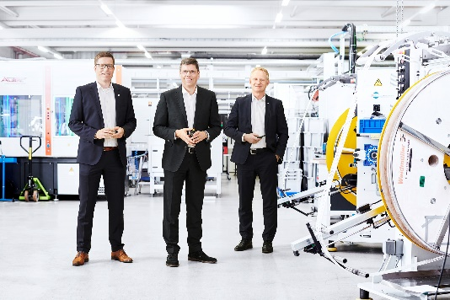
Image caption: 2021_PK_Vorstand_Weidmüller_Gruppe
Overall, the Executive Board of the Weidmüller Group looks back on a challenging 2020 and is confident for 2021.

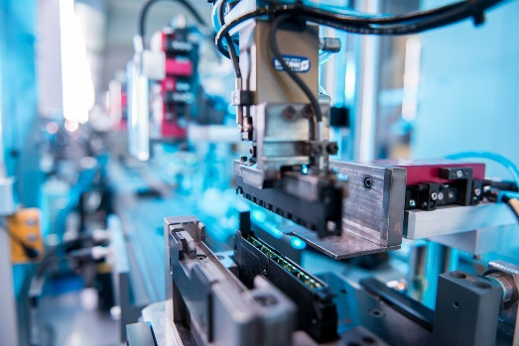
Image caption: 2021_PK_Fertigung
State-of-the-art production lines ensure efficient production and consistently high quality.

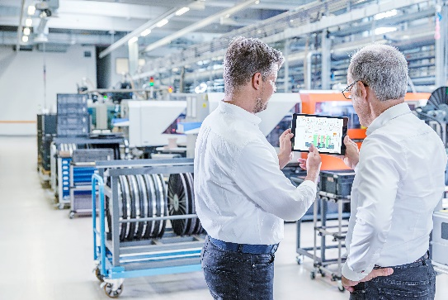
Image caption: PPL_IIoT_Appl_AML_Tablet_1
Weidmüller Industrial Automated Machine Learning Tool: Machine Learning easy to use without expert knowledge in Data Science – Automated Modelling.

Weidmüller – a partner for Industrial Connectivity
The Weidmüller Group has production facilities, sales companies and representatives in more than 80 countries. Together with our customers, we shape the digital transformation – with products, solutions and services for Smart Industrial Connectivity and the Industrial Internet of Things. In the 2020 financial year, Weidmüller generated sales of €792 million with around 5,000 employees.

Contact Weidmüller Corporate Communications
Corporate Spokesperson, Sybille Hilker
Tel.: +49 5231/14-292322
E-mail: presse@weidmueller.com

